

**CAPSTONE PROJECT REPORT**

**Report 4 – Software Design Specification**

– Hanoi, April 2025 –

**Table of Contents**

I. Record of Changes 3

II. Software Design Document 4

1. System Design 4

1.1 System Architecture 4

1.2 Package Diagram 7

2. Database Design 11

3. Detail Design 14

3.1 Authentication and Authorization 14

3.2 User Management 16

4. Class Specification 45

4.1 Controller 45

4.2 Service 51

4.3 Entity 57

# I. Record of Changes

| **Date** | **A* M, D** | **In charge** | **Change Description** |
| --- | --- | --- | --- |
|  |  |  |  |
|  |  |  |  |
|  |  |  |  |
|  |  |  |  |
|  |  |  |  |
|  |  |  |  |
|  |  |  |  |
|  |  |  |  |
|  |  |  |  |
|  |  |  |  |
|  |  |  |  |
|  |  |  |  |
|  |  |  |  |

*A - Added M - Modified D - Deleted

# II. Software Design Document

## 1. System Design

## 

### *1.1 System Architecture*

#### 1.1.1 . Design

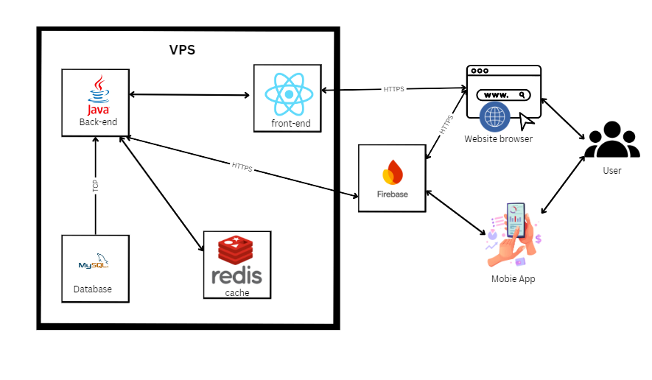

Figure 4.1: System Architecture

#### 1.1.2 . Component Explanation

1.1.2.1 . Spring boot (Java 17)



Java Spring Boot is a powerful software development framework used to build server-side HR management applications, APIs, and other back-end functionalities for the GF-HRMS system. It offers a flexible and easy-to-configure development environment and supports deployment across multiple platforms.

1.1.2.2. React



React is a JavaScript library used to develop the user interface for the GF-HRMS system. It helps build dynamic web interfaces that are easy to use and responsive to users.

1.1.2.3. MySQL



MySQL is a relational database management system (RDBMS) used to store and manage human resources data in the GF-HRMS system. It is known for its reliability, ease of use, and strong support for structured queries. MySQL also provides solid performance, scalability, and security for managing HR-related transactions and data.

1.1.2.4. FireBase



* Firebase is a comprehensive platform developed by Google that provides cloud-based services for building and managing applications, including those related to human resources in the GF-HRMS system. It offers real-time database management, cloud storage, authentication services, and hosting. Firebase ensures seamless synchronization of HR data across multiple clients, improves application responsiveness, and enhances security with robust access control and authentication mechanisms.  
    
  1.1.2.5. Redis  
    
     
      
  Redis (Remote Dictionary Server) is a source-available, in-memory storage, used as a distributed, in-memory key–value database, cache and message broker, with optional durability. Because it holds all data in memory and because of its design, Redis offers low-latency reads and writes, making it particularly suitable for use cases that require a cache. Redis is the most popular NoSQL database, and one of the most popular databases overall. Redis is used in companies like Twitter, Airbnb, Tinder, Yahoo, Adobe, Hulu, Amazon and OpenAI.

### *1.2 Package Diagram*

### 

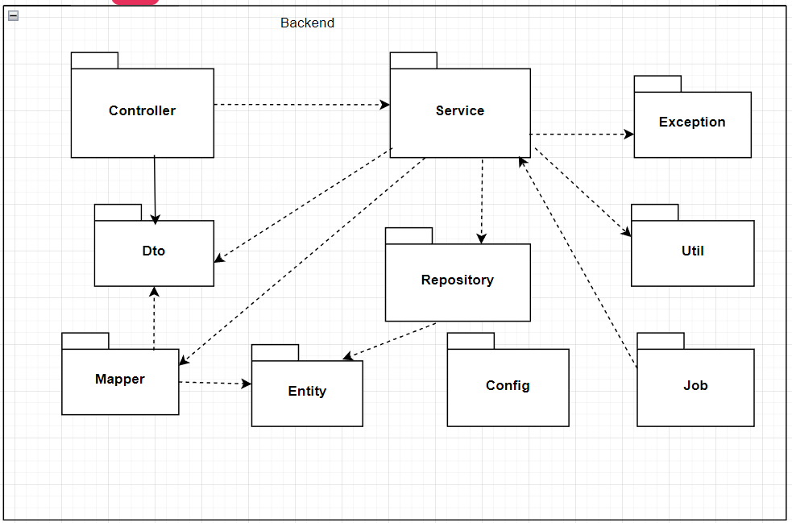

Figure 4.2: Package Diagram backend  
Package Descriptions for backend

| No | Package | Description |
| --- | --- | --- |
| 01 | Controller | Process requests from clients |
| 02 | Service | Contains business logic (main business of the system) |
| 03 | Repository | Communicate directly with database |
| 04 | Dto | Helps control information display and validate data input. |
| 05 | Mapper | Converts between Entity and DTO |
| 06 | Entity | Represents tables in the database |
| 07 | Exception | Error management and handling (Exception handling). |
| 08 | Util | Utility classes (utility classes). |
| 09 | Config | System configuration (configuration) |
| 10 | Job | Defines jobs that run automatically over time |

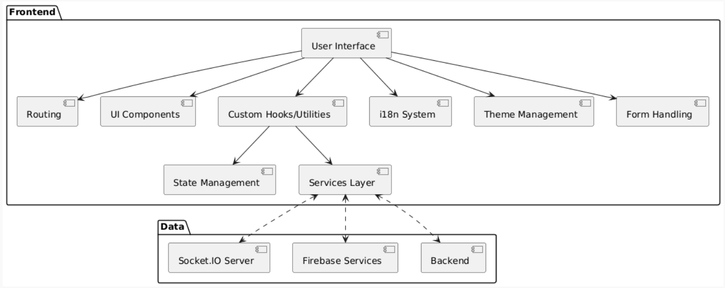  
Figure 4.2: Package Diagram Frontend  
Package Descriptions for Frontend

| No | Package | Description |
| --- | --- | --- |
| 01 | User Interface | Responsible for displaying the interface to the user, depends on many other packages to perform specific functionality |
| 02 | Routing | Manage Navigation between different pages or sections of the web when the user interacts, this package will determine what content to display |
| 03 | UI Components | Contains reusable user interface components. This UI will use components to display to the user. |
| 04 | State Management | Manage web states when data or web state changes, this package will update notifications to the relevant UI so they can re-render. |
| 05 | Services Layer | Responsible for communicating with BE or other data sources. These Services can make API calls to process the returned data. |
| 06 | Custom Hooks/Utilities | Contains Custom Hooks or utility functions used throughout the website to perform specific tasks or share logic. |
| 07 | i18n System | Responsible for displaying multilingual content |
| 08 | Theme Management | Manage the appearance of the website, allowing us to change colors, fonts, etc. |
| 09 | Form Handling | Handles the logic of creating, collecting, and validating data through user forms. |
| 10 | Socket.IO Server | Can be used for real-time communication between FE and BE |
| 11 | Firebase Services | Includes services: Cloud, Storage. Applies to receiving notifications and images. |
| 12 | Backend | Represents the Server-Side of the website, where we process business logic and data |

Figure 4.2: Package Diagram Mobile  
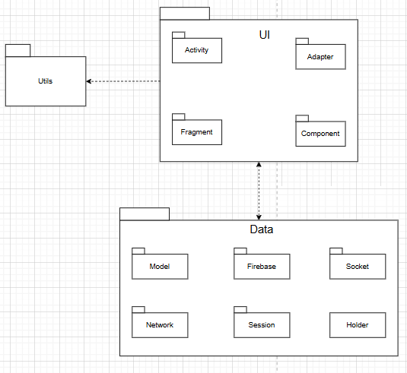

Package Descriptions for Mobile App

| No | Package | Description |
| --- | --- | --- |
| 01 | Activity | Contains Activity classes, which are the main components in Android applications, responsible for managing the user interface (UI) and handling user interactions with specific screens. |
| 02 | Adapter | Stores Adapter classes, used to connect data to interface components such as ListView, RecyclerView, which help display data in the form of lists or grids |
| 03 | Fragment | Contains Fragment classes, which are modular UI components that can be reused in Activities, helping to manage the interface flexibly, especially on devices with large screens. |
| 04 | Component | Includes reusable or modular components (such as UI components, custom views), which help increase reusability and better organize code. |
| 05 | Model | Stores data model classes, which represent the application's data structure, often used to store and process data from APIs or databases. |
| 06 | Firebase | Contains code related to integrating and using Firebase, such as database management (Firestore), user authentication, or push notifications (FCM). |
| 07 | Socket | Includes classes that handle socket connections (WebSocket or TCP), often used for real-time communication between clients and servers, for example for chat or live data updates. |
| 08 | Network | Contains classes related to network handling, such as calling APIs (usually using Retrofit, OkHttp), managing HTTP requests, and handling responses from the server. |
| 09 | Session | Manages user sessions, such as storing login information, authentication tokens, or session state in the application. |
| 10 | Holder | Usually contains ViewHolder classes, used in Adapters to optimize list display (for example, in RecyclerView), helping to reuse views and reduce rendering costs. |
| 11 | Utils | Includes utility classes, containing common support functions such as string processing, date and time formatting, or other utility functions used throughout the application. |

Table 4.1: Package Descriptions

## 2. Database Design

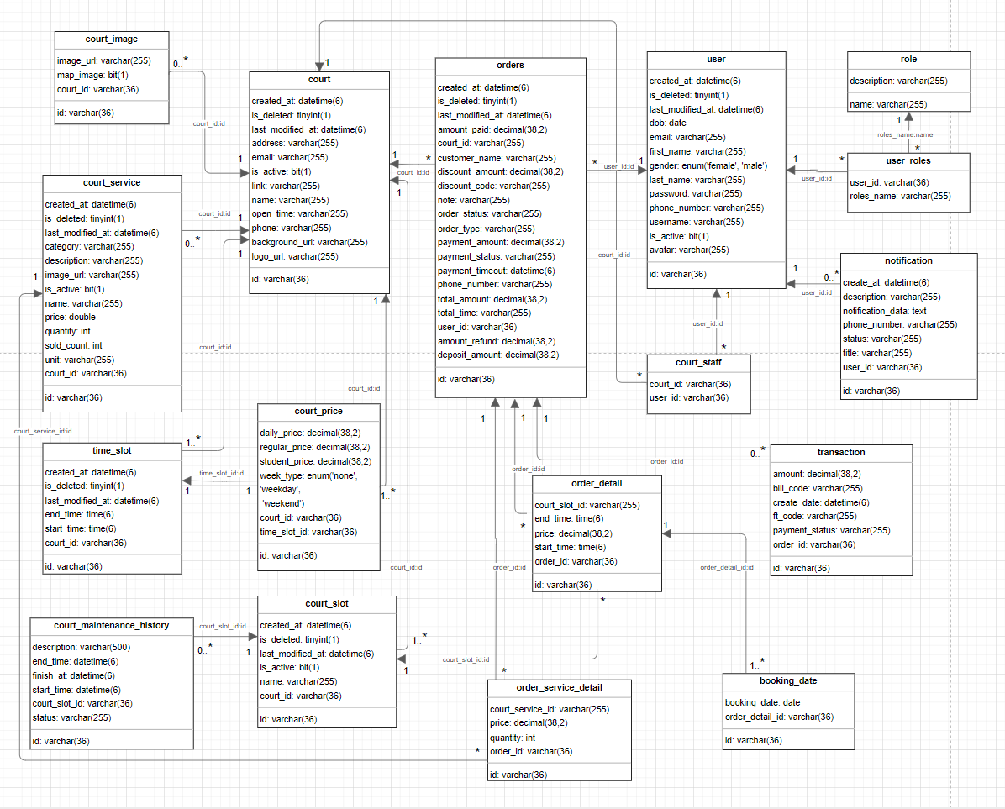

Figure 4.3: Database Design

Table Descriptions

| No | Table | Description |
| --- | --- | --- |
| 01 | court | Stores information about pickleball courts, including name, address, opening hours, owner and manager details, contact info (email, phone), logo, background image, activity status, and associated links. |
| 02 | user | Contains user information such as first name, gender, date of birth, phone number, email, password, avatar, student status, membership type (bronze, silver, gold, diamond), username, and the court they are associated with. |
| 03 | role | Defines user roles such as admin, staff, and regular user. |
| 04 | permission | Lists system permissions like creating courts, managing bookings, handling payments, etc. |
| 05 | role_permissions | Junction table linking roles to their corresponding permissions, determining what each role is allowed to do. |
| 06 | user_roles | Junction table linking users to their roles. A user can have one or more roles. |
| 07 | time_slot | Stores available time slots for court operation (e.g., 8:00 AM – 10:00 AM). Used to configure available booking times. |
| 08 | court_price | Defines pricing for court bookings by time slot and court, including regular price, student price, daily price, and the type of day (none, weekday, weekend). |
| 09 | court_slot | Represents specific court slots available for booking, including name, court reference, and status (active or deleted). |
| 10 | order_detail | Details each slot within a booking (start and end time, court slot info, price). Each record is linked to a booking (order_id). |
| 11 | orders | Stores booking information including customer name, contact, court details, address, order type, total time, status, discounts, payments, deposits, and refund info. |
| 12 | transaction | Contains transaction records tied to orders, including payment amount, status, bill code, transaction code, and creation date. |
| 13 | notification | Manages notifications sent to users, including content, status, and recipient user ID. |

Table 4.2: Table Descriptions Database Design

Table 4.2: Table Descriptions Database Design

### 2.1. Court

| No | Field | PK | FK | UN | NN | Description |
| --- | --- | --- | --- | --- | --- | --- |
| 1 | id | ✓ |  | ✓ | ✓ | Unique identifier for the court (UUID) |
| 2 | created_at |  |  |  | ✓ | Timestamp when the court record was created |
| 3 | last_modified_at |  |  |  | ✓ | Timestamp when the court record was last updated |
| 4 | is_deleted |  |  |  | ✓ | Flag indicating if the court is marked as deleted |
| 5 | name |  |  | ✓ | ✓ | Name of the court |
| 6 | address |  |  |  | ✓ | Physical address of the court |
| 7 | phone |  |  |  | ✓ | Contact phone number for the court |
| 8 | open_time |  |  |  |  | Operating hours of the court |
| 9 | is_active |  |  |  |  | Flag indicating if the court is currently active |
| 10 | email |  |  |  |  | Email contact for the court |
| 11 | link |  |  |  |  | Website or other relevant link |
| 12 | logo_url |  |  |  |  | URL to the court's logo image |
| 13 | background_url |  |  |  |  | URL to the court's background image |

### 2.2. Court Image

| No | Field | PK | FK | UN | NN | Description |
| --- | --- | --- | --- | --- | --- | --- |
| 1 | id | ✓ |  | ✓ | ✓ | Unique identifier for the court image (UUID) |
| 2 | court_id |  | ✓ |  | ✓ | Reference to the associated court |
| 3 | image_url |  |  |  | ✓ | URL to the image file |
| 4 | map_image |  |  |  |  | Flag: true = map/layout image; false = regular photo |

### 2.3. Court Service

| No | Field | PK | FK | UN | NN | Description |
| --- | --- | --- | --- | --- | --- | --- |
| 1 | id | ✓ |  | ✓ | ✓ | Unique identifier for the court service (UUID) |
| 2 | created_at |  |  |  | ✓ | Timestamp when the service record was created |
| 3 | last_modified_at |  |  |  | ✓ | Timestamp when the service record was last updated |
| 4 | is_deleted |  |  |  | ✓ | Flag indicating if the service is marked as deleted |
| 5 | court_id |  | ✓ |  | ✓ | Reference to the associated court |
| 6 | category |  |  |  | ✓ | Category of the service (e.g., Equipment, Refreshments) |
| 7 | name |  |  |  | ✓ | Name of the service |
| 8 | price |  |  |  | ✓ | Price of the service |
| 9 | quantity |  |  |  | ✓ | Available quantity |
| 10 | unit |  |  |  | ✓ | Unit of measure (e.g., hour, piece) |
| 11 | description |  |  |  |  | Detailed description |
| 12 | image_url |  |  |  |  | URL to an image representing the service |
| 13 | is_active |  |  |  | ✓ | Flag indicating if the service is currently available |
| 14 | sold_count |  |  |  |  | Counter tracking how many times the service has been sold |

### 2.4. Time Slot

| No | Field | PK | FK | UN | NN | Description |
| --- | --- | --- | --- | --- | --- | --- |
| 1 | id | ✓ |  | ✓ | ✓ | Unique identifier for the time slot (UUID) |
| 2 | created_at |  |  |  | ✓ | Timestamp when the time slot was created |
| 3 | last_modified_at |  |  |  | ✓ | Timestamp when the time slot was updated |
| 4 | is_deleted |  |  |  | ✓ | Flag indicating if the slot is deleted |
| 5 | court_id |  | ✓ |  | ✓ | Reference to the associated court |
| 6 | start_time |  |  |  | ✓ | Start time of the slot |
| 7 | end_time |  |  |  | ✓ | End time of the slot |

### 2.5. Court Slot

| No | Field | PK | FK | UN | NN | Description |
| --- | --- | --- | --- | --- | --- | --- |
| 1 | id | ✓ |  | ✓ | ✓ | Unique identifier for the court slot (UUID) |
| 2 | created_at |  |  |  | ✓ | Timestamp when the court slot was created |
| 3 | last_modified_at |  |  |  | ✓ | Timestamp when the court slot was updated |
| 4 | is_deleted |  |  |  | ✓ | Flag indicating if the court slot is deleted |
| 5 | court_id |  | ✓ |  | ✓ | Reference to the associated court |
| 6 | name |  |  |  | ✓ | Name of the court slot |
| 7 | is_active |  |  |  | ✓ | Flag indicating if the court slot is active |

### 2.6. Court Maintenance History

| No | Field | PK | FK | UN | NN | Description |
| --- | --- | --- | --- | --- | --- | --- |
| 1 | id | ✓ |  | ✓ | ✓ | Unique identifier for the maintenance record (UUID) |
| 2 | court_slot_id |  | ✓ |  | ✓ | Reference to the associated court slot |
| 3 | start_time |  |  |  | ✓ | Scheduled start time of maintenance |
| 4 | end_time |  |  |  | ✓ | Scheduled end time of maintenance |
| 5 | finish_at |  |  |  |  | Actual completion time |
| 6 | description |  |  |  |  | Description of the maintenance work |
| 7 | status |  |  |  |  | Current status (e.g., Scheduled, In Progress, Completed) |

### 2.7. Court Price

| No | Field | PK | FK | UN | NN | Description |
| --- | --- | --- | --- | --- | --- | --- |
| 1 | id | ✓ |  | ✓ | ✓ | Unique identifier for the court price (UUID) |
| 2 | court_id |  | ✓ |  | ✓ | Reference to the associated court |
| 3 | time_slot_id |  | ✓ |  | ✓ | Reference to the associated time slot |
| 4 | week_type |  |  |  | ✓ | Type of week (WEEKDAY or WEEKEND) |
| 5 | regular_price |  |  |  |  | Regular price for recurring customers |
| 6 | daily_price |  |  |  | ✓ | Daily price for walk-in customers |
| 7 | student_price |  |  |  |  | Discounted price for students |

### 2.8. Orders

| No | Field | PK | FK | UN | NN | Description |
| --- | --- | --- | --- | --- | --- | --- |
| 1 | id | ✓ |  | ✓ | ✓ | Unique identifier for the order (UUID) |
| 2 | created_at |  |  |  | ✓ | Timestamp when the order was created |
| 3 | last_modified_at |  |  |  | ✓ | Timestamp when the order was updated |
| 4 | is_deleted |  |  |  | ✓ | Flag indicating if the order is deleted |
| 5 | court_id |  |  |  | ✓ | Reference to the associated court |
| 6 | customer_name |  |  |  | ✓ | Name of the customer |
| 7 | phone_number |  |  |  | ✓ | Customer contact phone number |
| 8 | note |  |  |  |  | Additional notes |
| 9 | order_type |  |  |  | ✓ | Type of order (e.g., Regular, Fixed Booking) |
| 10 | order_status |  |  |  | ✓ | Current status of the order |
| 11 | payment_status |  |  |  | ✓ | Current payment status |
| 12 | total_time |  |  |  |  | Total time booked |
| 13 | discount_code |  |  |  |  | Discount code applied |
| 14 | total_amount |  |  |  | ✓ | Total amount |
| 15 | deposit_amount |  |  |  | ✓ | Required deposit |
| 16 | discount_amount |  |  |  |  | Discount amount |
| 17 | payment_amount |  |  |  |  | Amount to be paid |
| 18 | amount_paid |  |  |  |  | Amount already paid |
| 19 | amount_refund |  |  |  |  | Amount refunded |
| 20 | payment_timeout |  |  |  |  | Deadline for payment |
| 21 | user_id |  | ✓ |  |  | Reference to the associated user |

### 2.9. User

| No | Field | PK | FK | UN | NN | Description |
| --- | --- | --- | --- | --- | --- | --- |
| 1 | id | ✓ |  | ✓ | ✓ | Unique identifier for the user (UUID) |
| 2 | created_at |  |  |  | ✓ | Timestamp when the user was created |
| 3 | last_modified_at |  |  |  | ✓ | Timestamp when the user was updated |
| 4 | is_deleted |  |  |  | ✓ | Flag indicating if the user is deleted |
| 5 | username |  |  | ✓ |  | Username for login |
| 6 | password |  |  |  | ✓ | Hashed password |
| 7 | first_name |  |  |  |  | User's first name |
| 8 | last_name |  |  |  |  | User's last name |
| 9 | dob |  |  |  |  | Date of birth |
| 10 | email |  |  | ✓ |  | User's email address |
| 11 | phone_number |  |  | ✓ |  | User's phone number |
| 12 | gender |  |  |  |  | Enum: 'MALE', 'FEMALE', 'OTHER' |
| 13 | avatar |  |  |  |  | URL to profile picture |
| 14 | is_active |  |  |  | ✓ | Flag indicating if the account is active |

### 2.10. Role

| No | Field | PK | FK | UN | NN | Description |
| --- | --- | --- | --- | --- | --- | --- |
| 1 | name | ✓ |  | ✓ | ✓ | Unique identifier/name of the role |
| 2 | description |  |  |  |  | Description of the role & permissions |

### 2.11. User Roles

| No | Field | PK | FK | UN | NN | Description |
| --- | --- | --- | --- | --- | --- | --- |
| 1 | user_id | ✓ | ✓ |  | ✓ | Reference to the user |
| 2 | roles_name | ✓ | ✓ |  | ✓ | Reference to the role |

### 2.12. Notification

| No | Field | PK | FK | UN | NN | Description |
| --- | --- | --- | --- | --- | --- | --- |
| 1 | id | ✓ |  | ✓ | ✓ | Unique identifier for the notification (UUID) |
| 2 | create_at |  |  |  |  | Timestamp when the notification was created |
| 3 | description |  |  |  |  | Detailed content |
| 4 | notification_data |  |  |  |  | Additional structured data |
| 5 | phone_number |  |  |  |  | Related phone number |
| 6 | status |  |  |  |  | Status (e.g., Read, Unread) |
| 7 | title |  |  |  |  | Title or subject |
| 8 | user_id |  | ✓ |  |  | Reference to the associated user |

### 2.13. Court Staff

| No | Field | PK | FK | UN | NN | Description |
| --- | --- | --- | --- | --- | --- | --- |
| 1 | user_id | ✓ | ✓ |  | ✓ | Reference to the user |
| 2 | court_id | ✓ | ✓ |  | ✓ | Reference to the court |

### 2.14. Transaction

| No | Field | PK | FK | UN | NN | Description |
| --- | --- | --- | --- | --- | --- | --- |
| 1 | id | ✓ |  | ✓ | ✓ | Unique identifier (UUID) |
| 2 | amount |  |  |  | ✓ | Transaction amount |
| 3 | bill_code |  |  |  | ✓ | Reference billing code |
| 4 | create_date |  |  |  | ✓ | Timestamp when created |
| 5 | ft_code |  |  |  | ✓ | Financial transaction code |
| 6 | payment_status |  |  |  | ✓ | Payment status |
| 7 | order_id |  | ✓ |  |  | Reference to the associated order |

### 2.15. Order Detail

| No | Field | PK | FK | UN | NN | Description |
| --- | --- | --- | --- | --- | --- | --- |
| 1 | id | ✓ |  | ✓ | ✓ | Unique identifier (UUID) |
| 2 | court_slot_id |  |  |  | ✓ | Reference to the court slot |
| 3 | start_time |  |  |  | ✓ | Start time of the booking |
| 4 | end_time |  |  |  | ✓ | End time of the booking |
| 5 | price |  |  |  |  | Price for this booking |
| 6 | order_id |  | ✓ |  | ✓ | Reference to the associated order |

### 2.16. Order Service Detail

| No | Field | PK | FK | UN | NN | Description |
| --- | --- | --- | --- | --- | --- | --- |
| 1 | id | ✓ |  | ✓ | ✓ | Unique identifier (UUID) |
| 2 | court_service_id |  |  |  | ✓ | Reference to the court service |
| 3 | quantity |  |  |  | ✓ | Quantity ordered |
| 4 | price |  |  |  | ✓ | Price of the service |
| 5 | order_id |  | ✓ |  | ✓ | Reference to the associated order |

### 2.17. Booking Date

| No | Field | PK | FK | UN | NN | Description |
| --- | --- | --- | --- | --- | --- | --- |
| 1 | id | ✓ |  | ✓ | ✓ | Unique identifier (UUID) |
| 2 | booking_date |  |  |  | ✓ | Date of the booking |
| 3 | order_detail_id |  | ✓ |  | ✓ | Reference to the associated detail |

## 

## 3. Detailed Design

### *3.1 Authentication and Authorization*

#### 3.1.1 User Registration

#### 3.1.1.1 Class Diagram

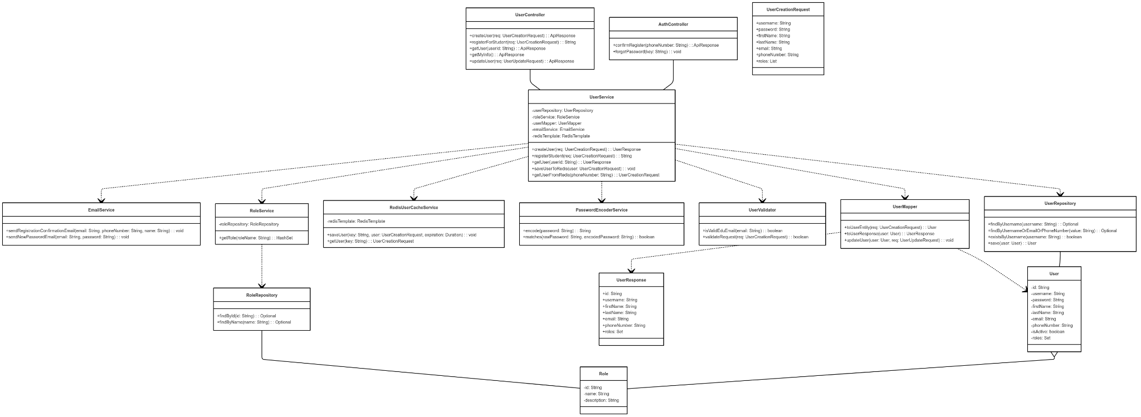

***link image: https://iili.io/3WtbzPa.png***

***3.1.1.2 Sequence Diagram***

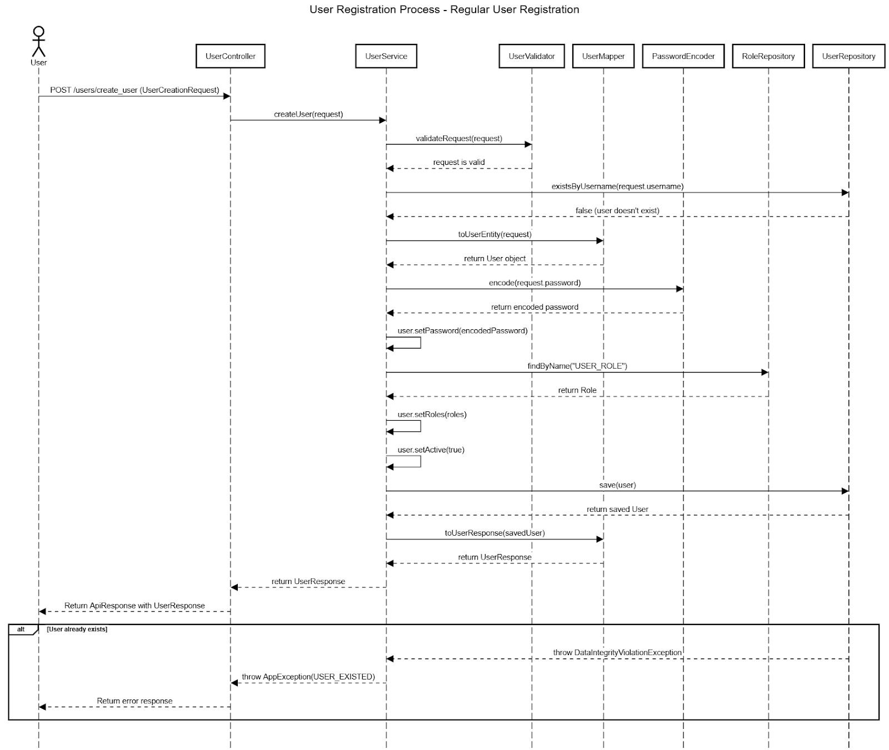

#### 3.1.2 Login

#### 3.1.2.1 Class Diagram

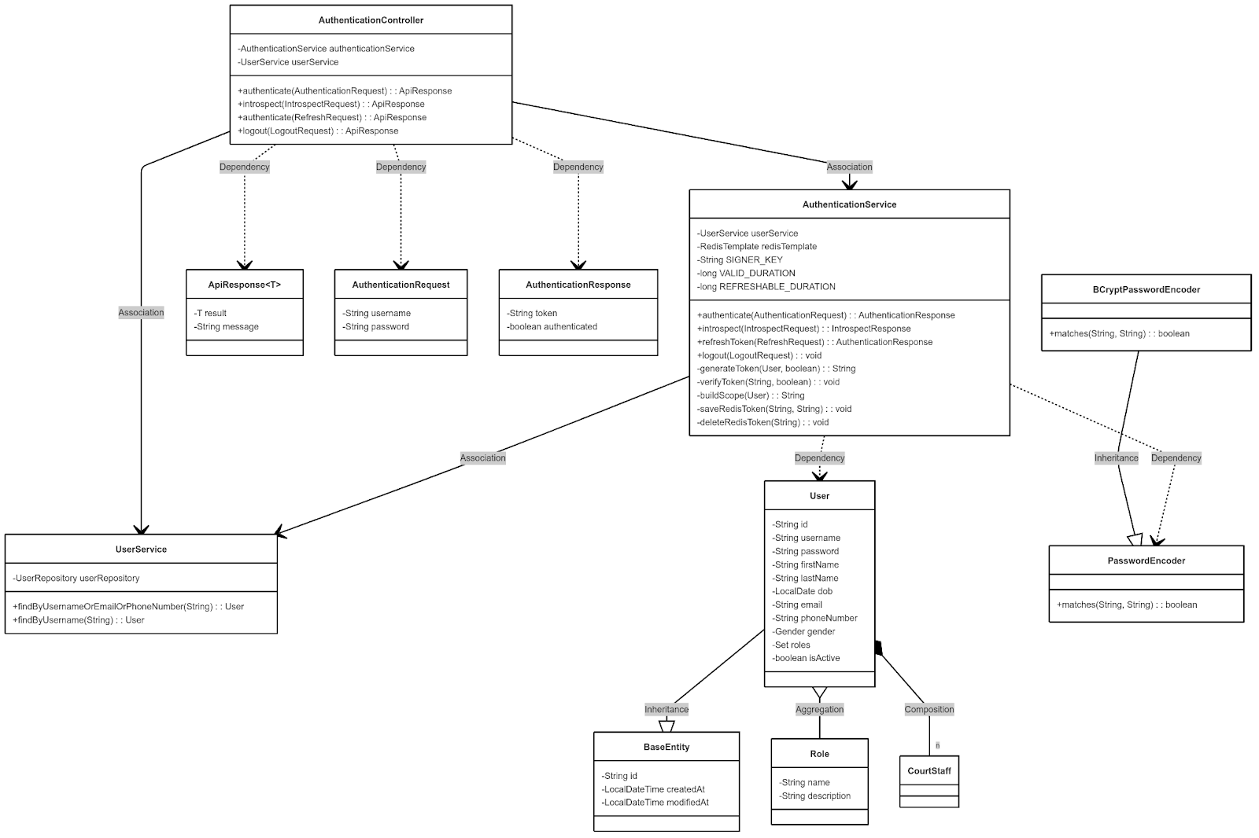

#### 3.1.2.2 Sequence Diagram

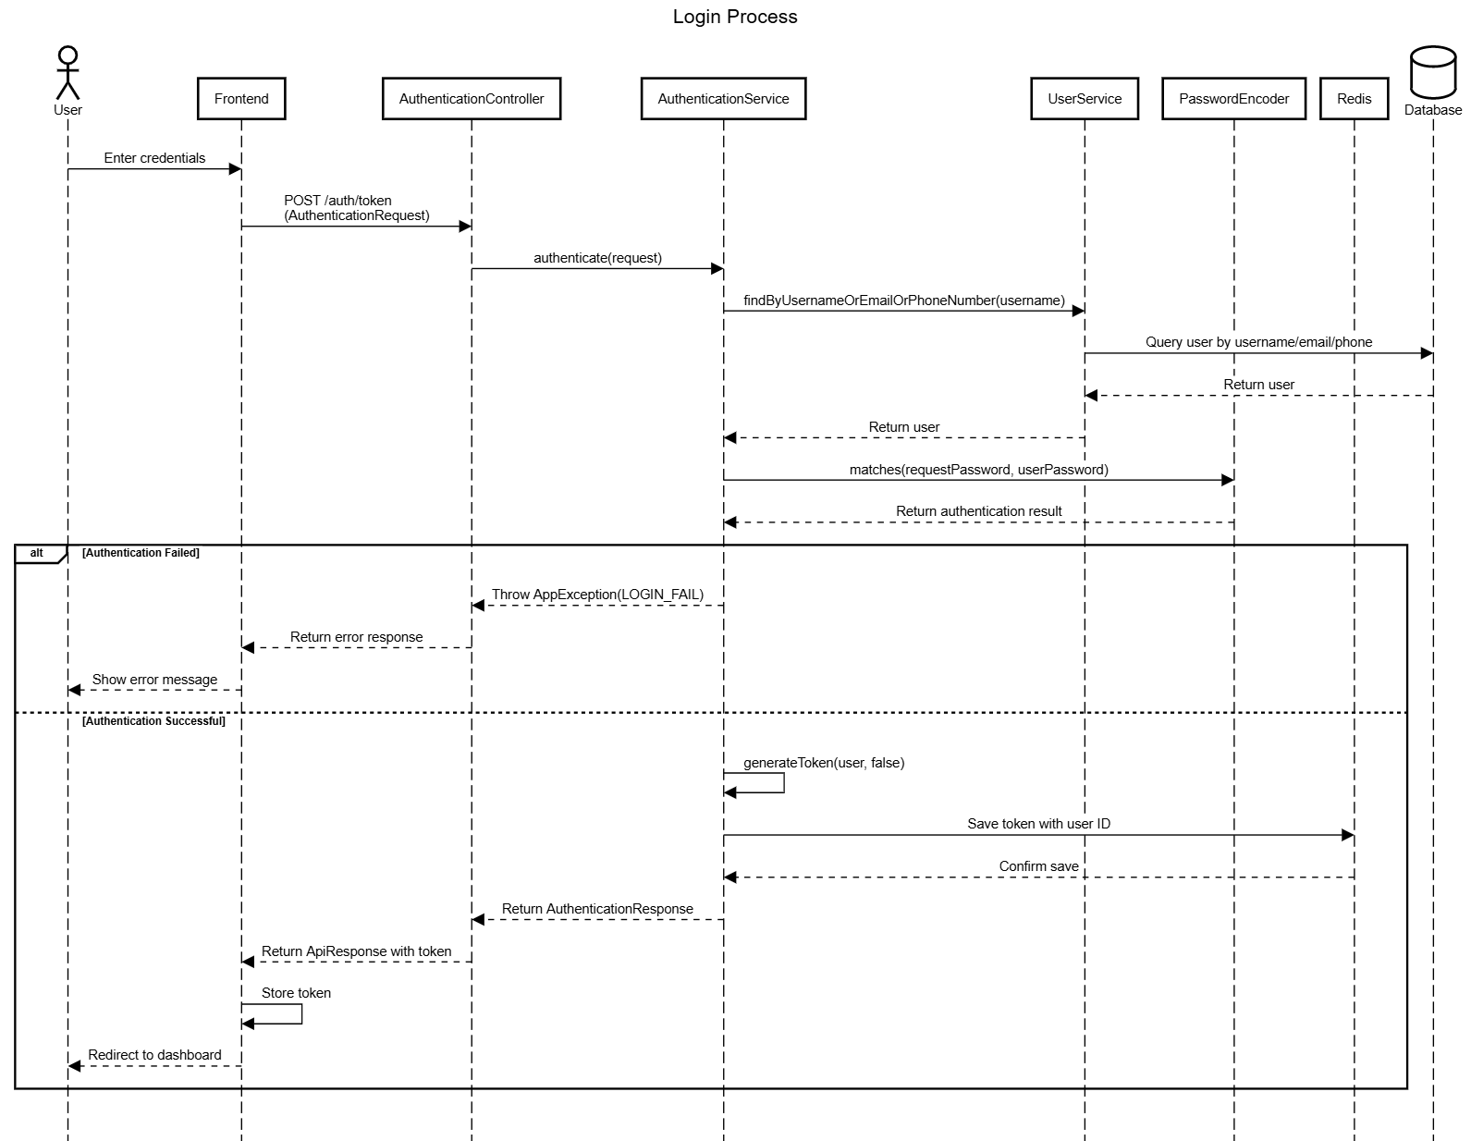

### *3.2 User Management*

#### 3.2.1 Class diagram

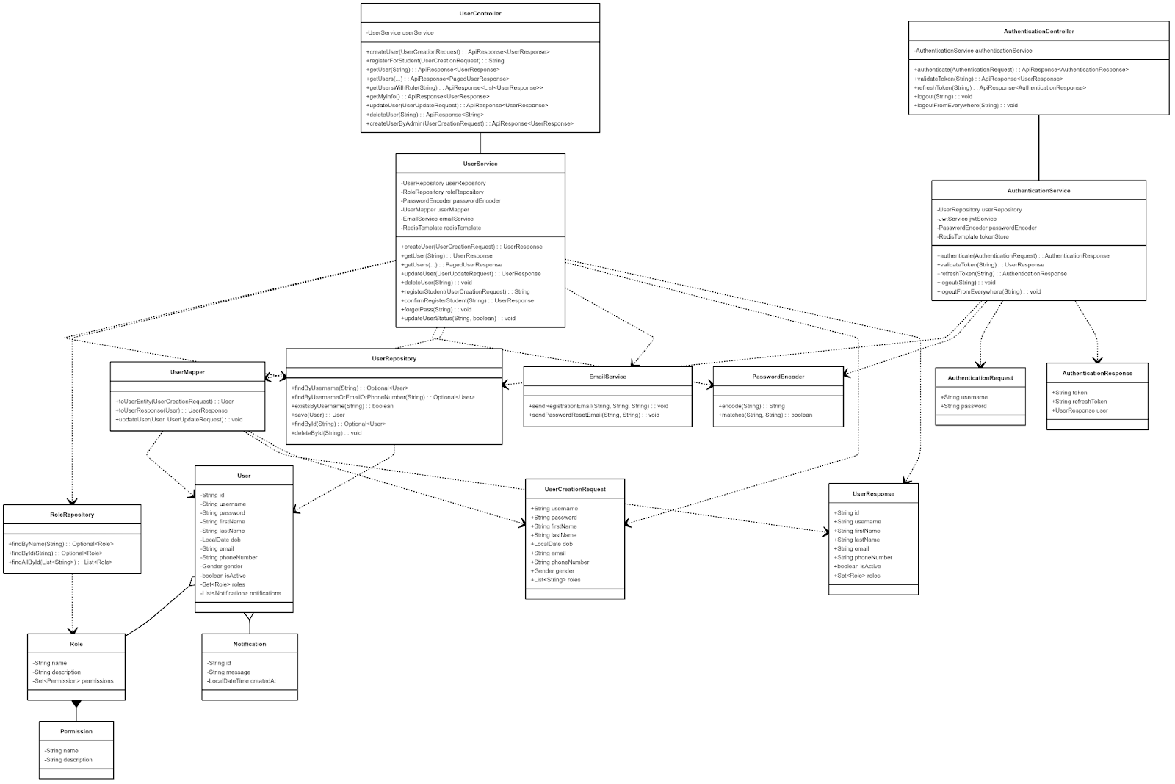

link image: https://iili.io/3WbXMyN.png

##### *3.2.2 Sequence Diagram*

##### *3.2.2.1 Basic Profile Management*

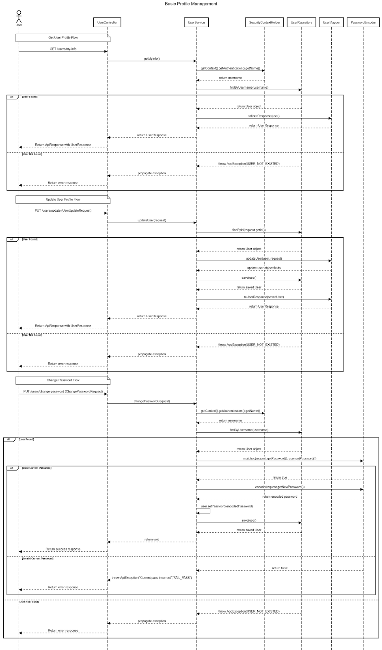

link image: https://iili.io/3WmZBLX.png

##### *3.2.2.2 Student Registration Process*

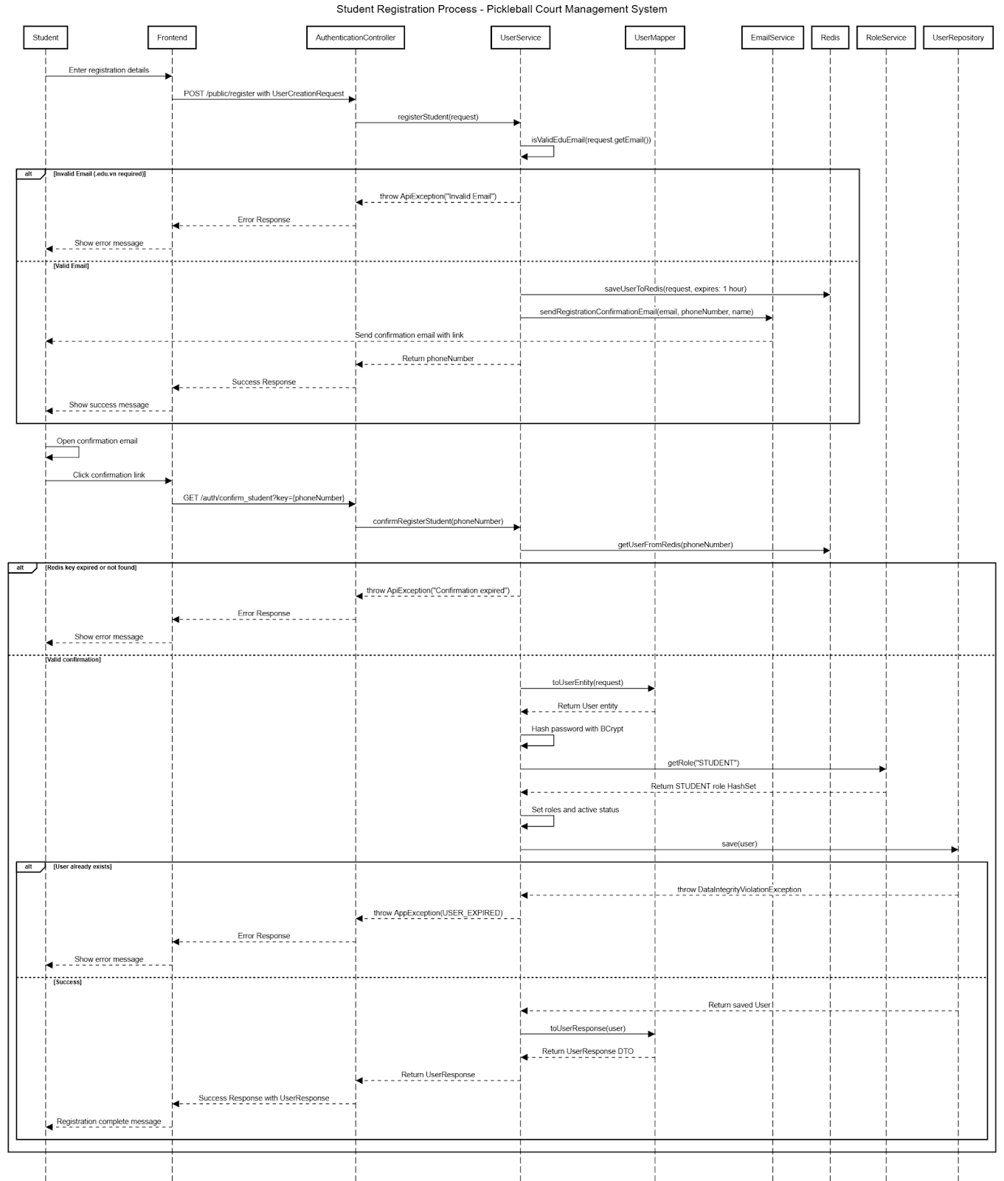

link image: https://iili.io/3WmtKaj.png

##### *3.2.2.3 Password Recovery Flow*

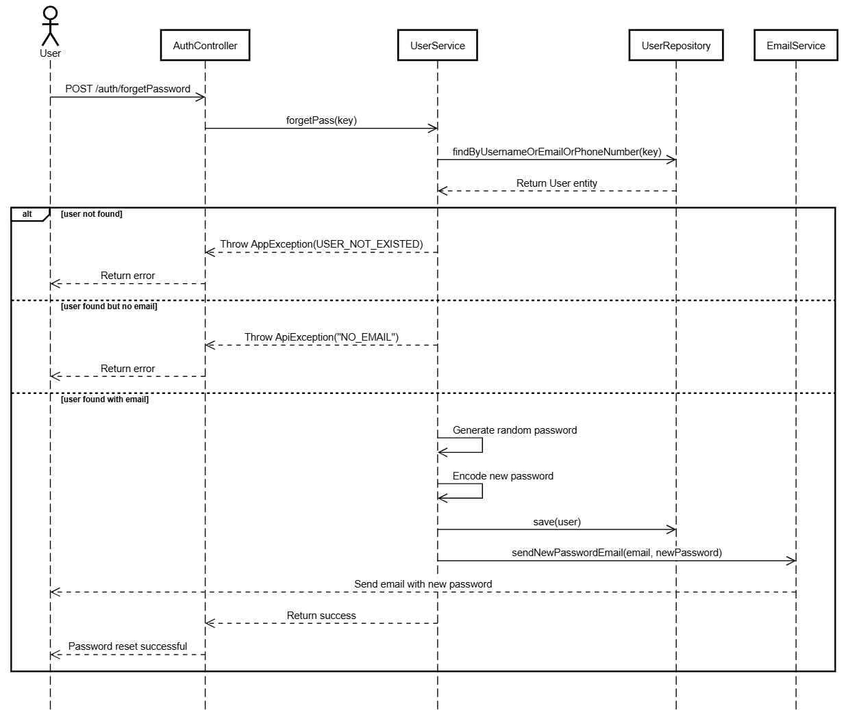

##### *3.2.2.4 Admin User Management*

##### *3.2.2.4.1 Get All Users Flow*

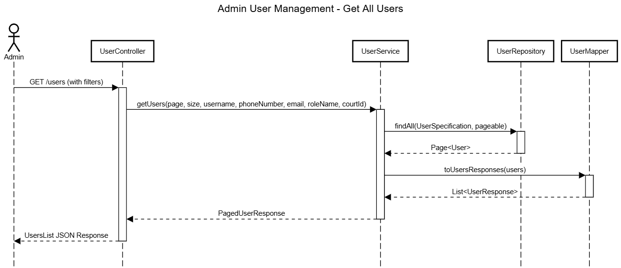

##### *3.2.2.4.2 Get Specific User Flow*

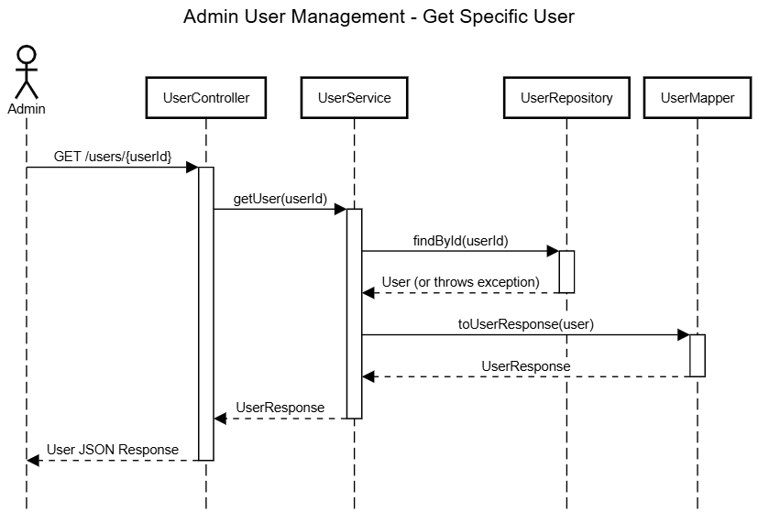

##### *3.2.2.4.3 Create User Flow*

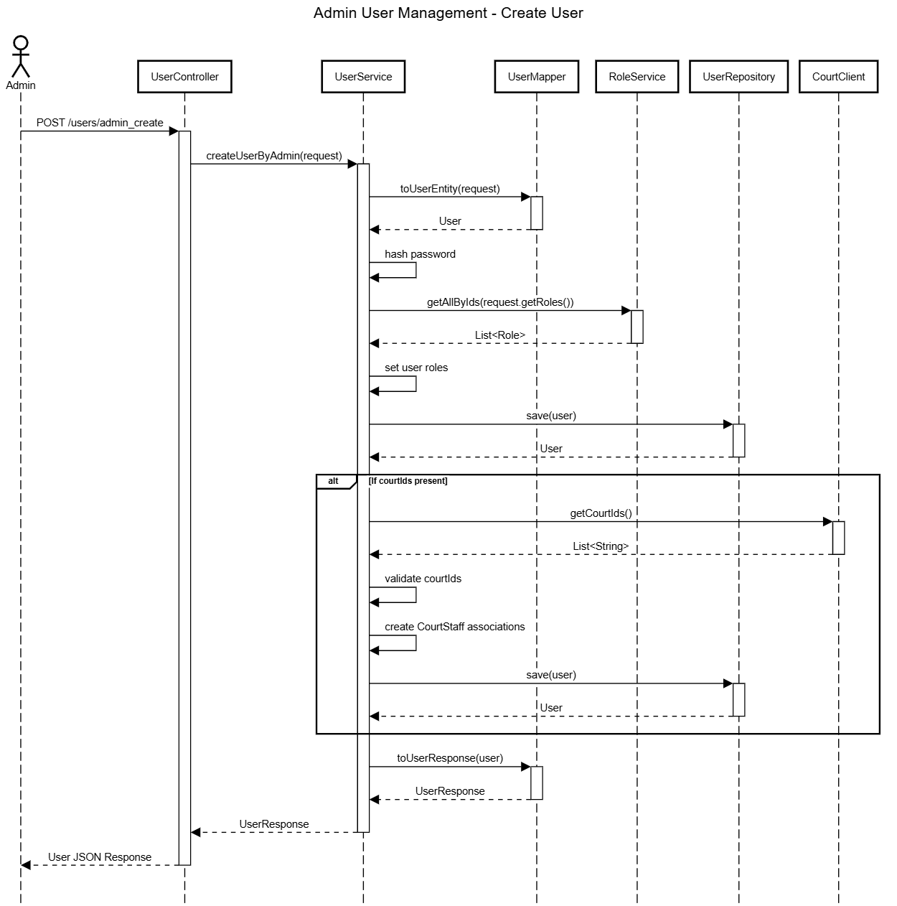

##### *3.2.2.4.4 Update User Flow*

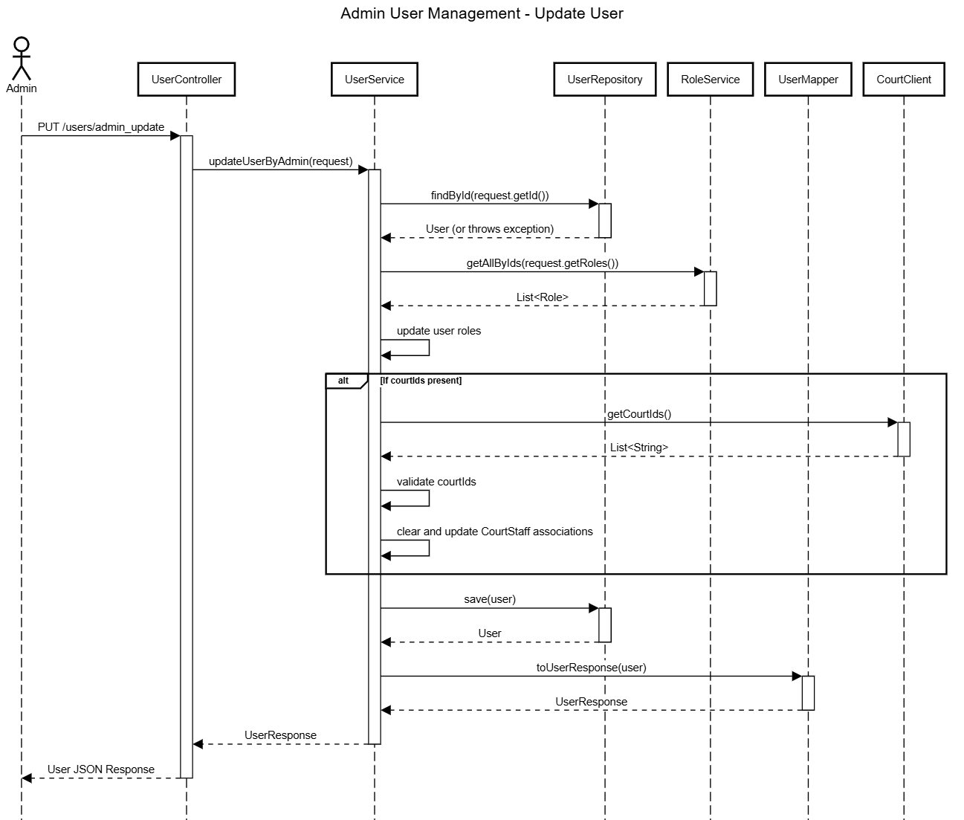

##### *3.2.2.4.5 Delete User Flow*

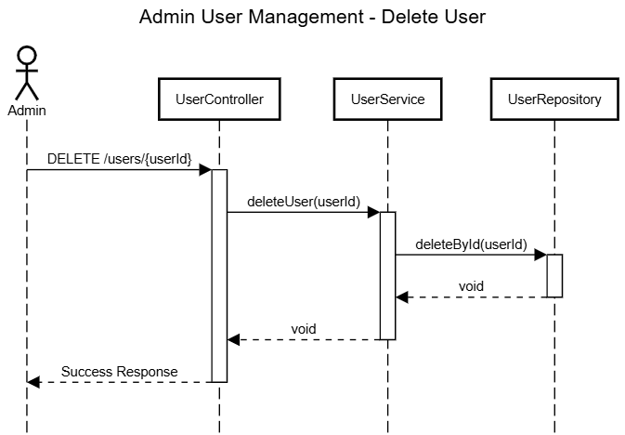

##### *3.2.2.4.6 Activate/Deactivate User Flow*

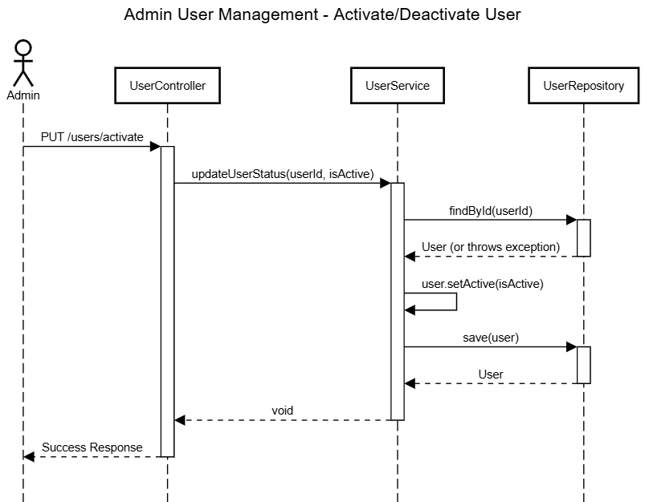

#### 3.2.3 Court management

##### *3.2.3.1 Create court and Setup*

##### *3.2.3.1.1 Class Diagram*

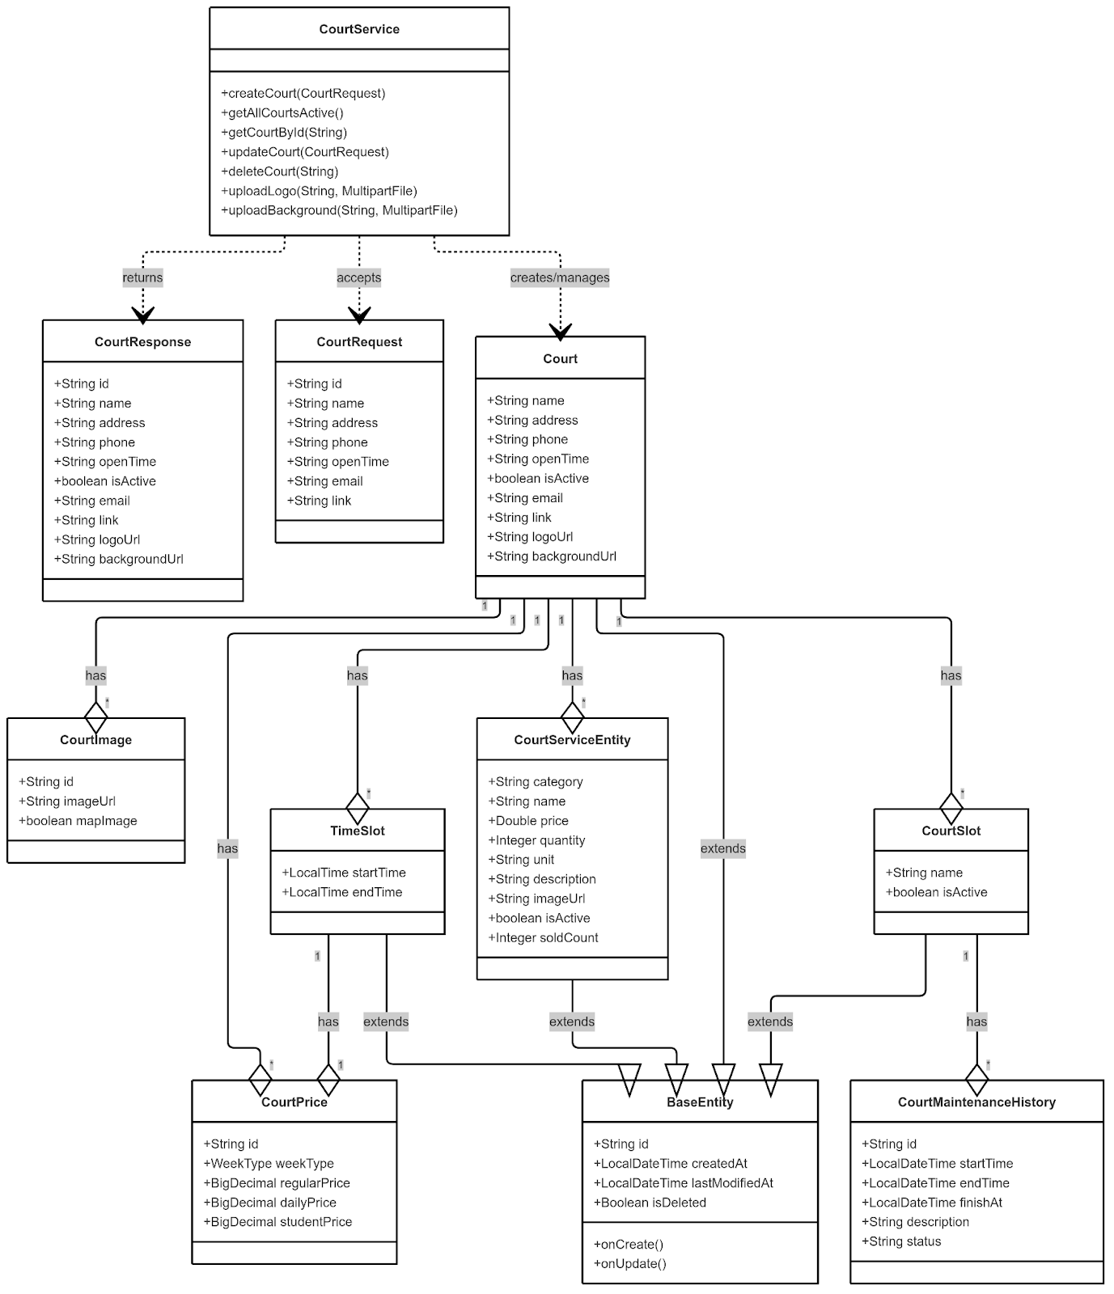

##### *3.2.3.1.2 Sequence Diagram*

##### *3.2.3.1.2.1 Create court*

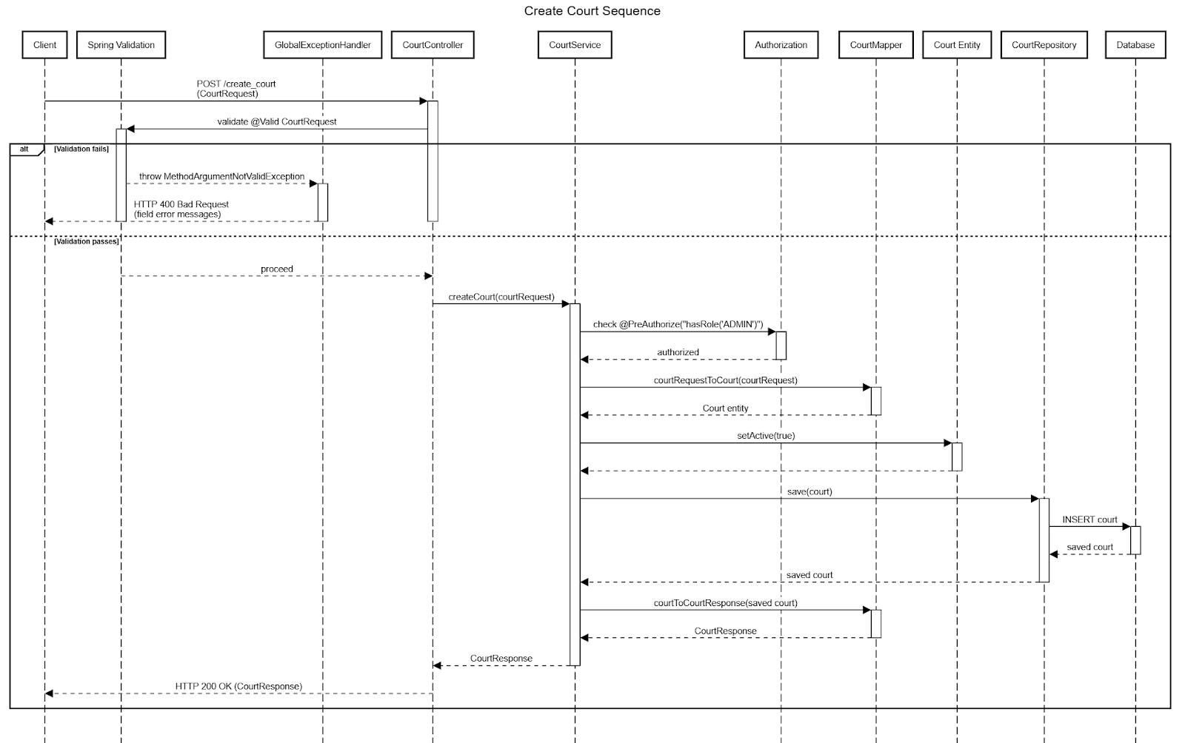

##### *3.2.3.1.2.2 Court Image Upload*

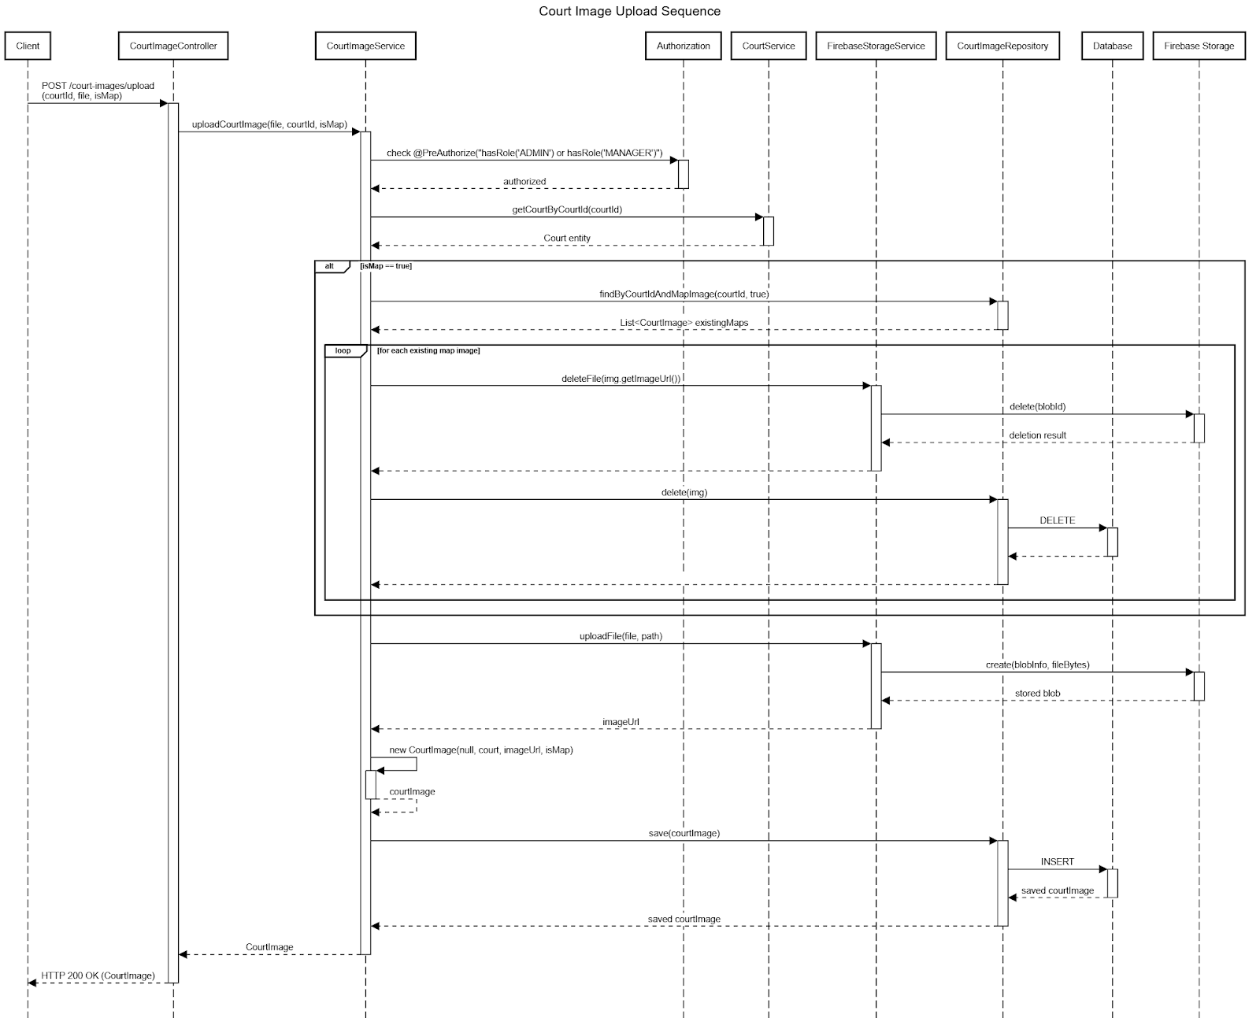

##### *3.2.3.2 Court Slot Configuration*

##### *3.2.3.2.1 Class Diagram*

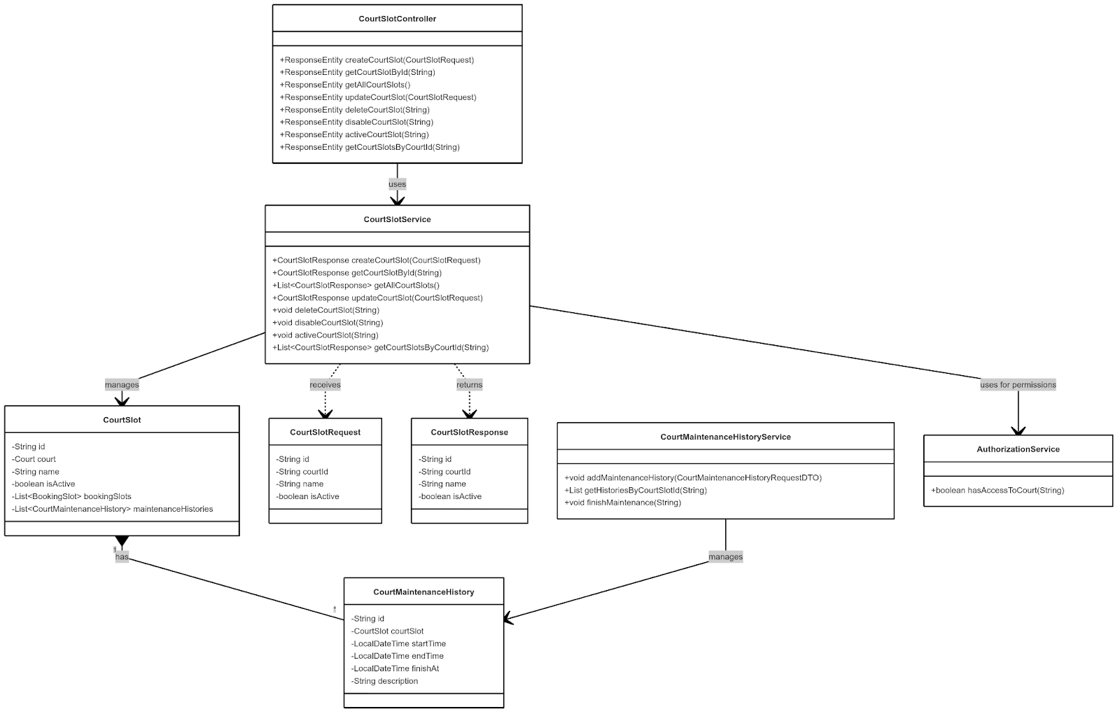

##### *3.2.3.2.2 Sequence Diagram*

##### *3.2.3.2.2.1 Court Slot Creation*

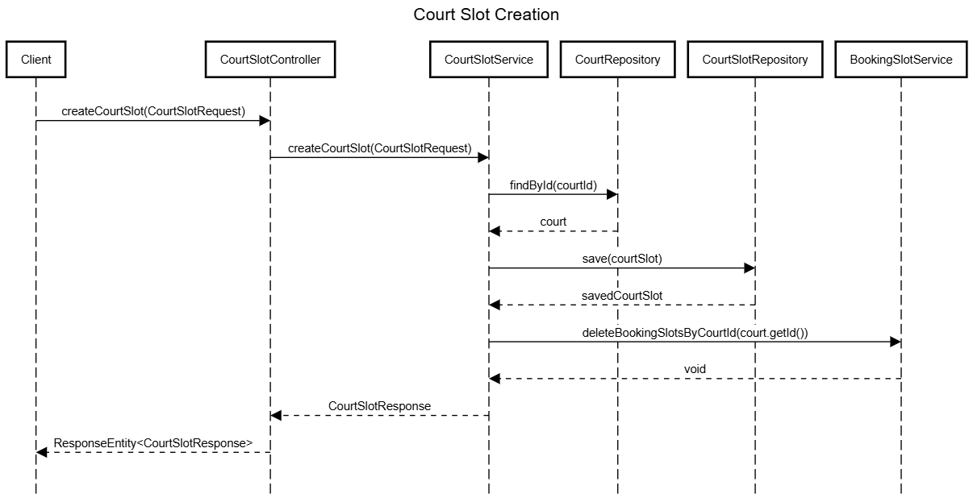

##### *3.2.3.2.2 Court Maintenance Scheduling*

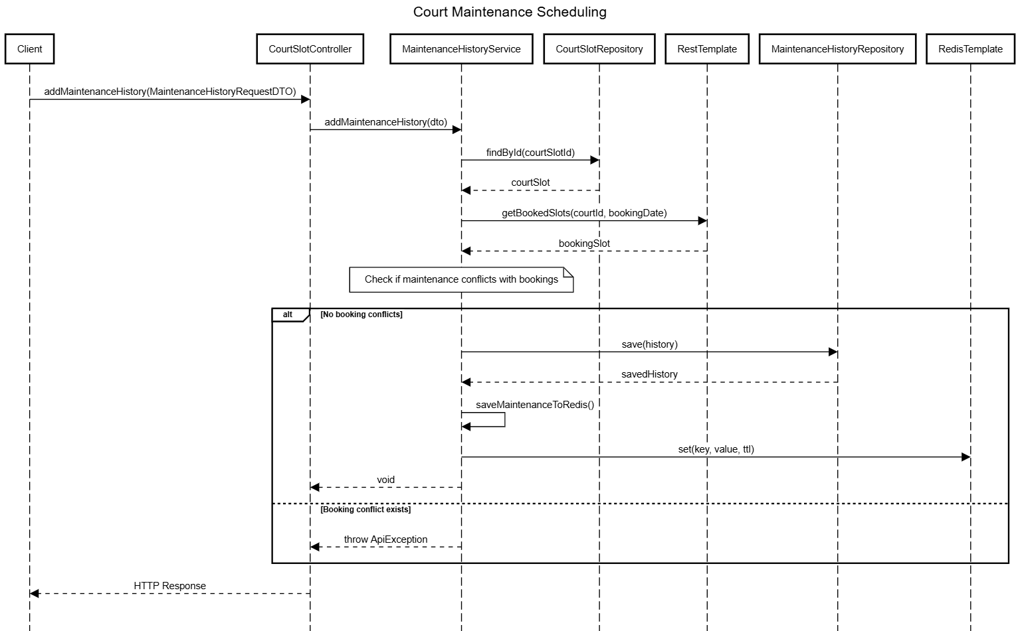

##### *3.2.3.3 Court Availability Management*

##### *3.2.3.3.1 Class Diagram*

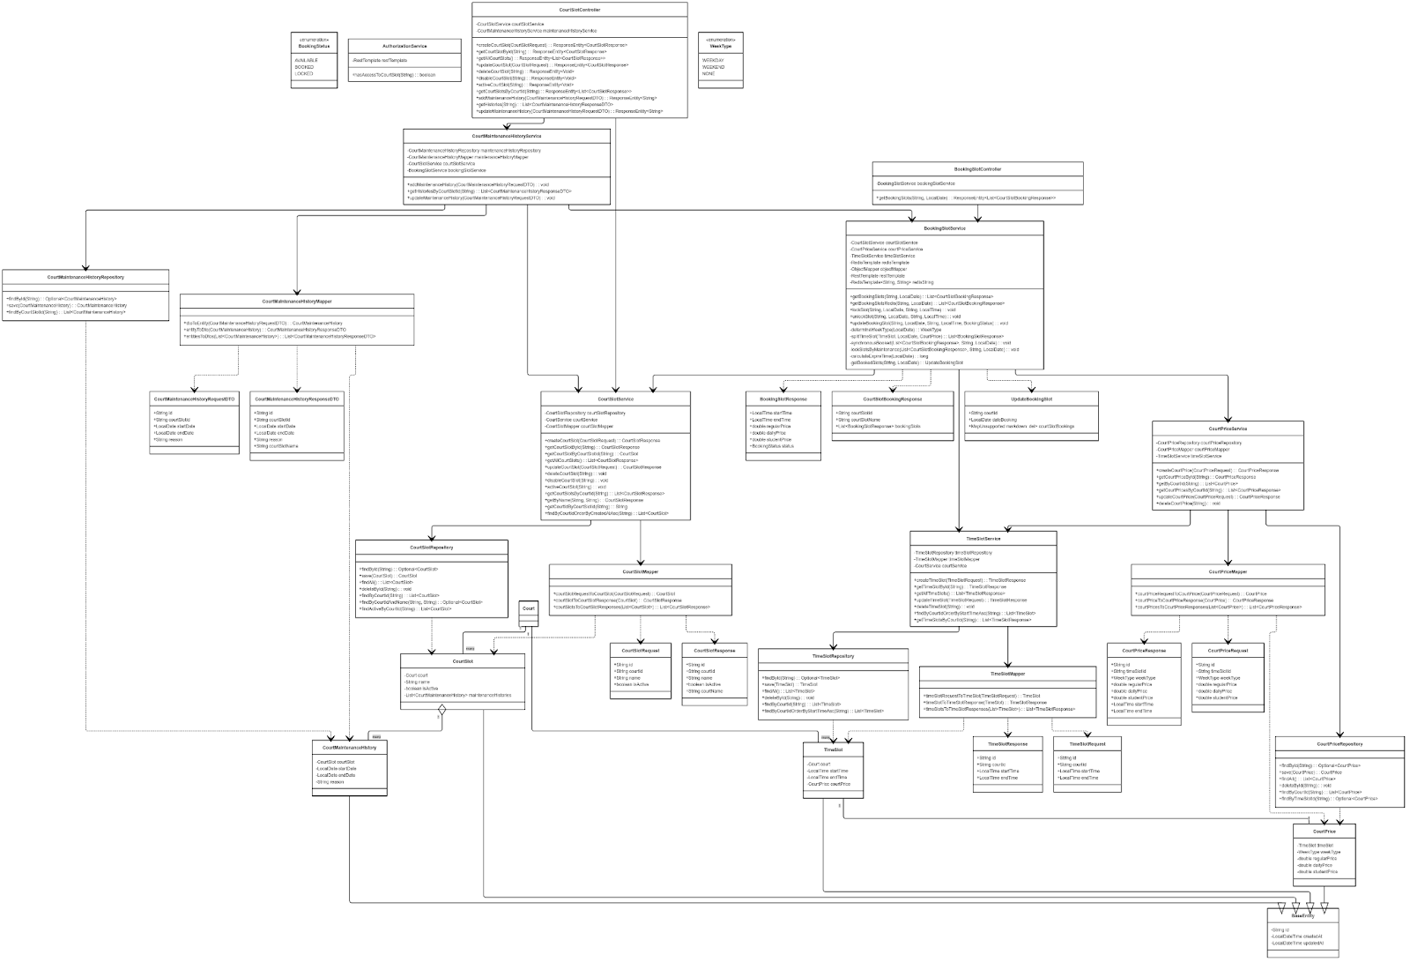

link image: https://iili.io/3E2o5B9.png

##### *3.2.3.3.2 Sequence Diagram*

##### *3.2.3.3.2.1 Update Booking Slots*

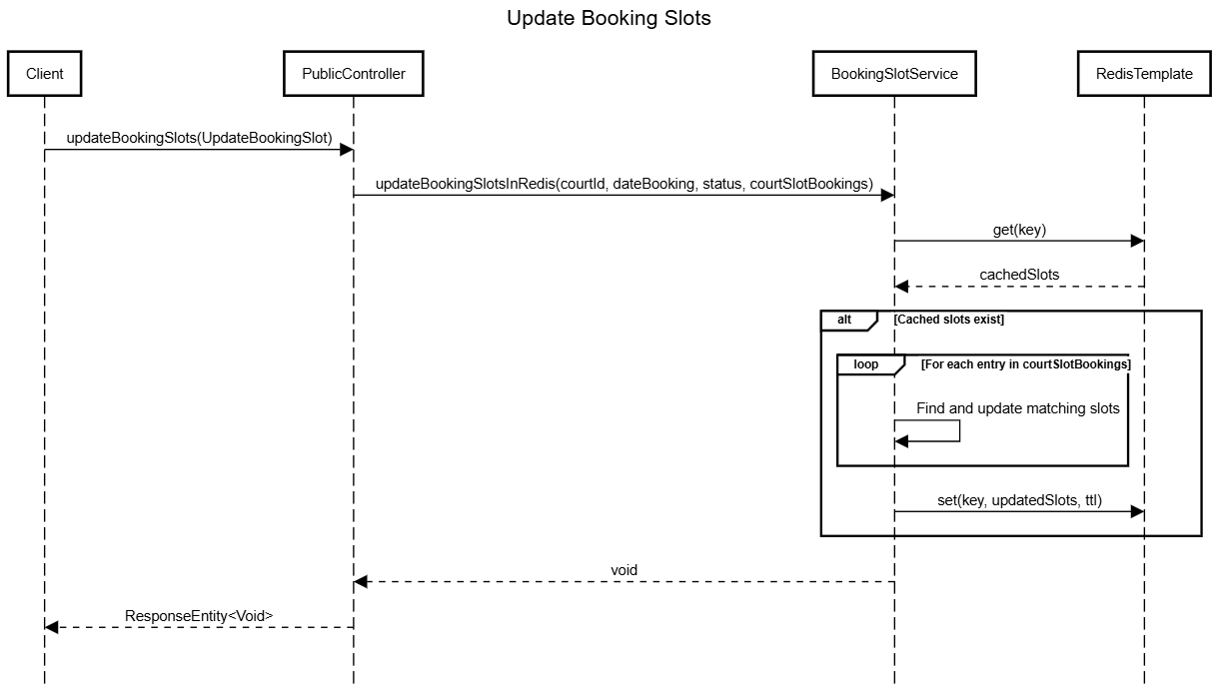

##### *3.2.3.4 Court Pricing Structure*

##### *3.2.3.4.1 Class Diagram*

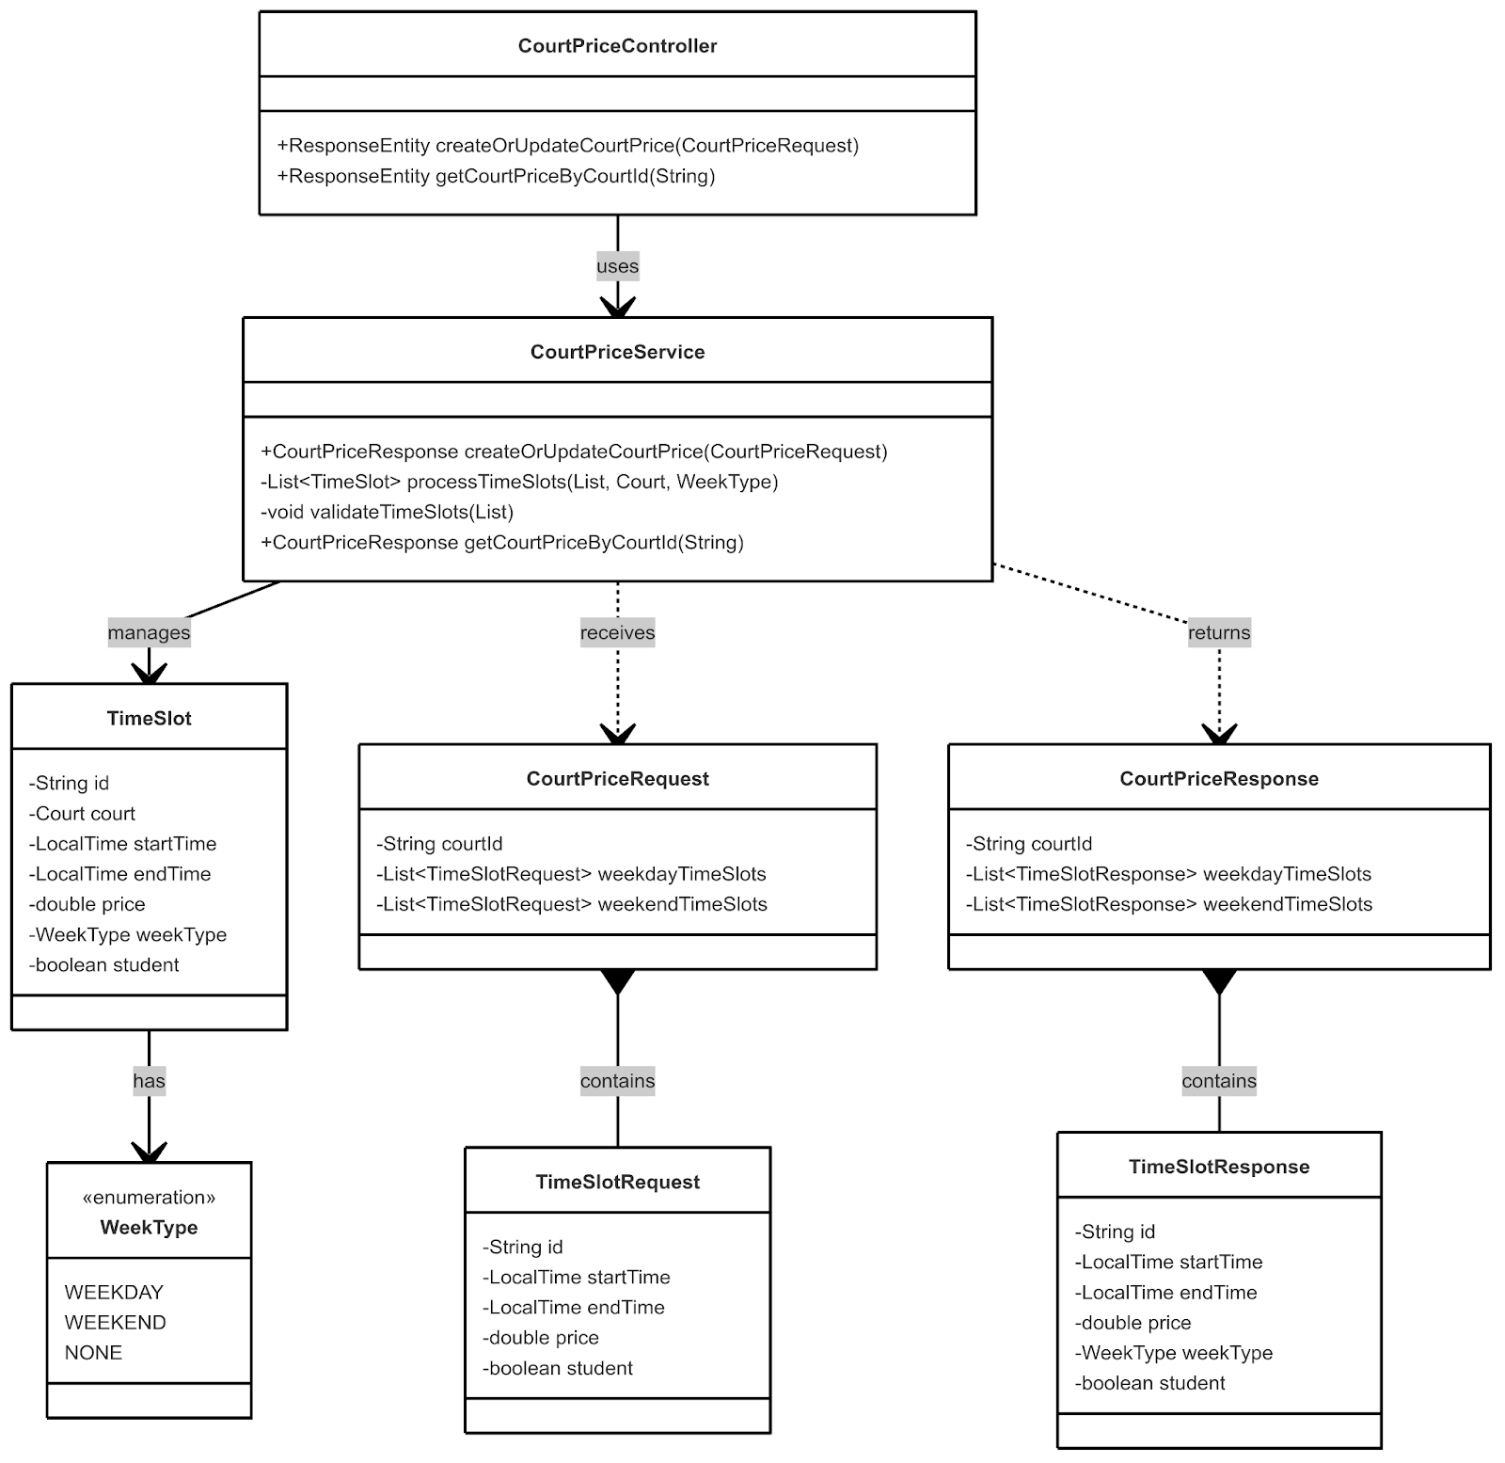

##### *3.2.3.4.2 Sequence Diagram*

##### *3.2.3.4.2.1 Court Price Configuration*

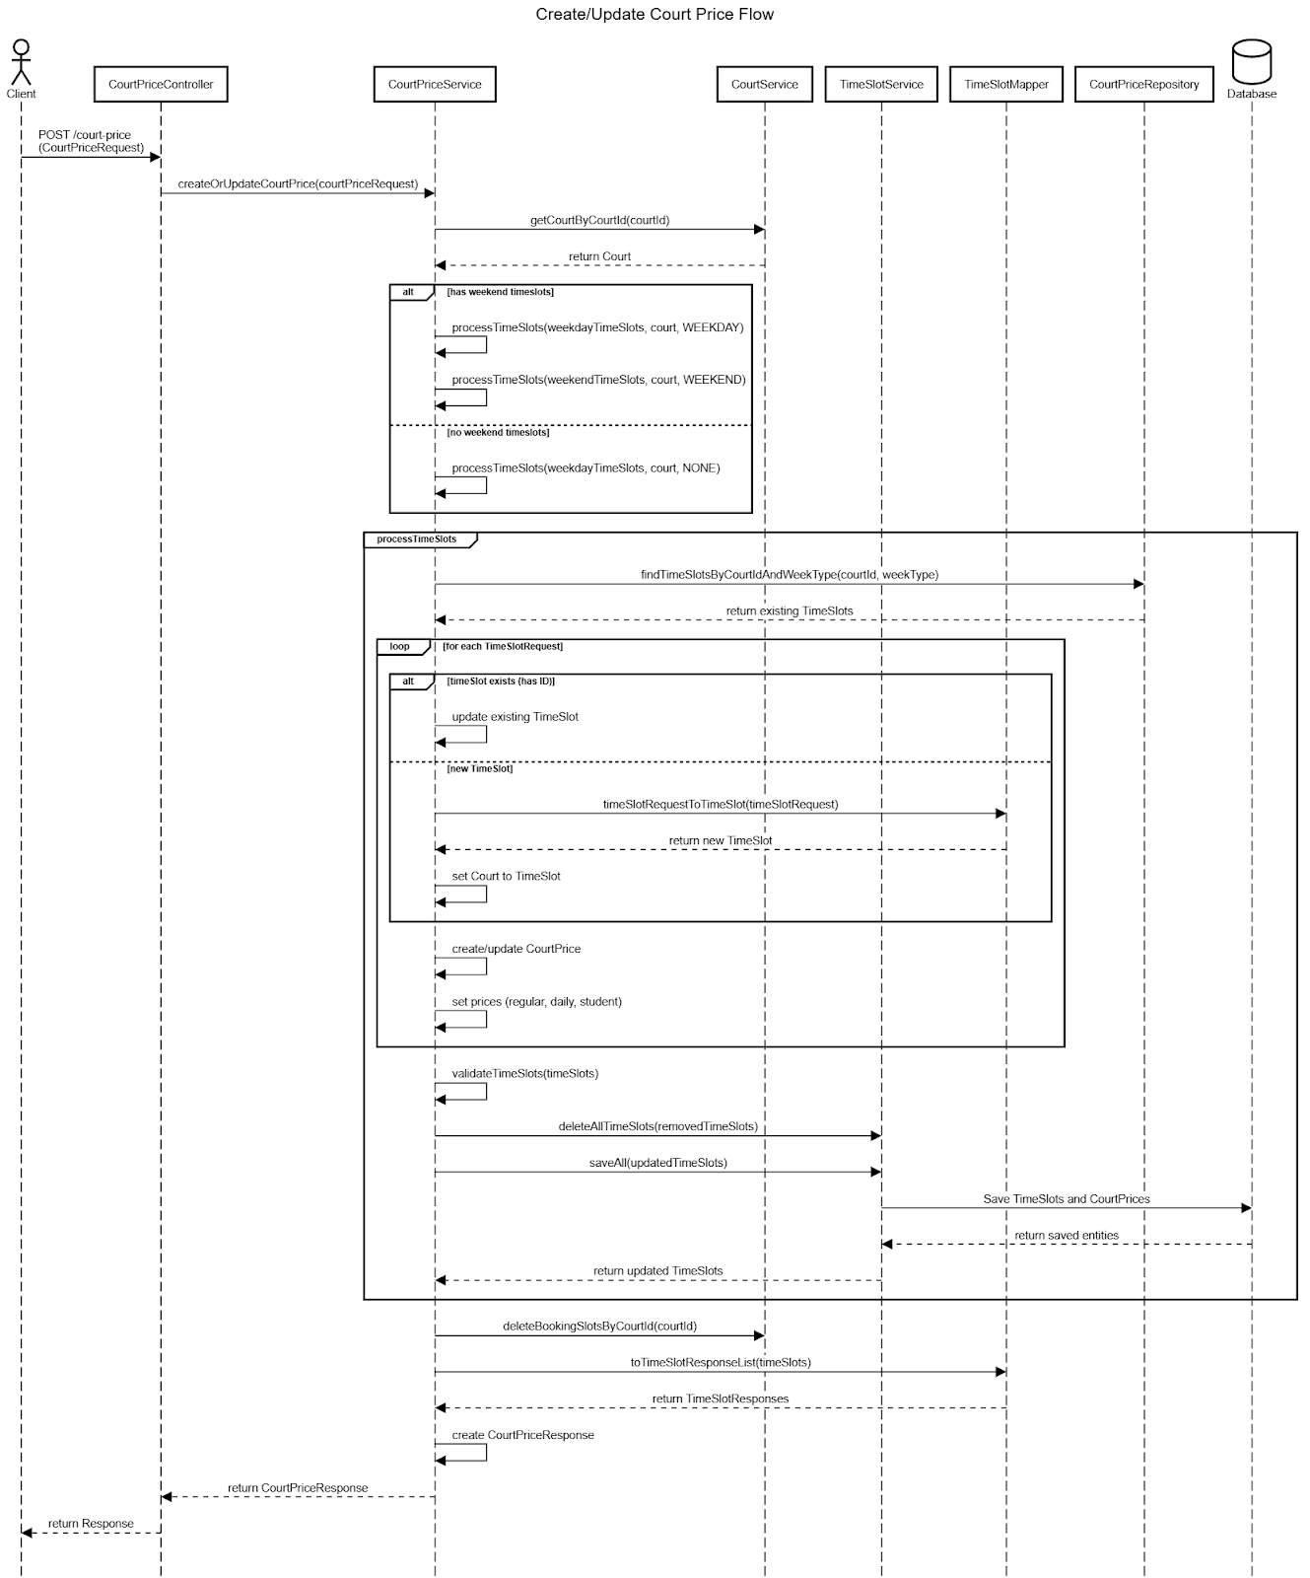

##### *3.2.3.4.2.2 Get Court Prices*

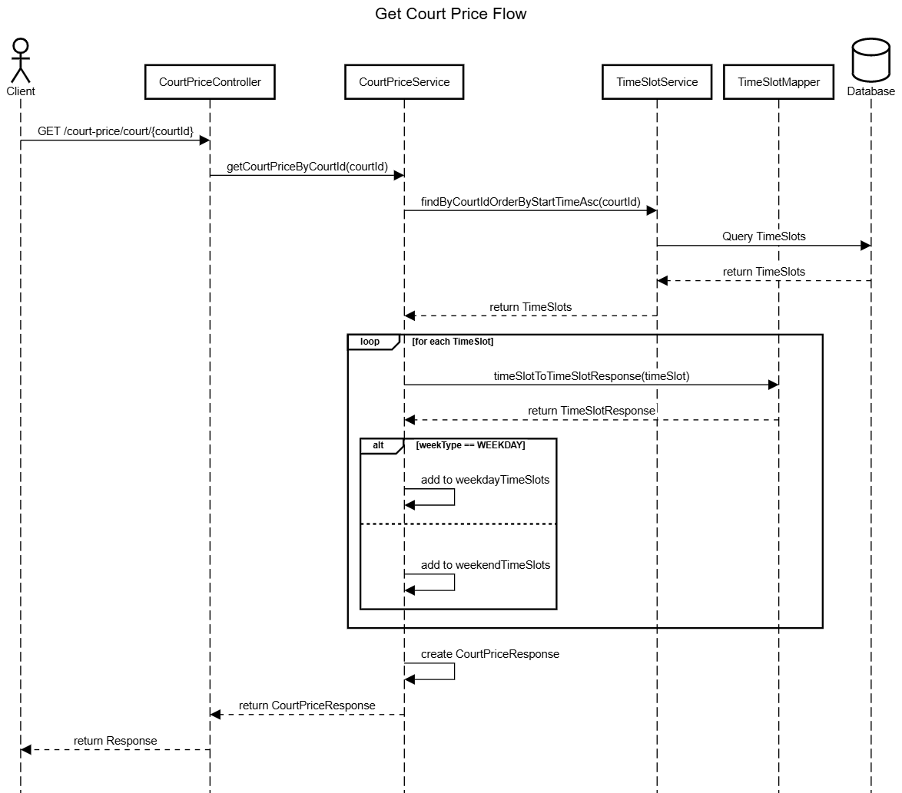

##### *3.2.4 Booking System*

##### *3.2.4.1 Daily Booking Creation Process*

##### *3.2.4.1.1 Class Diagram*

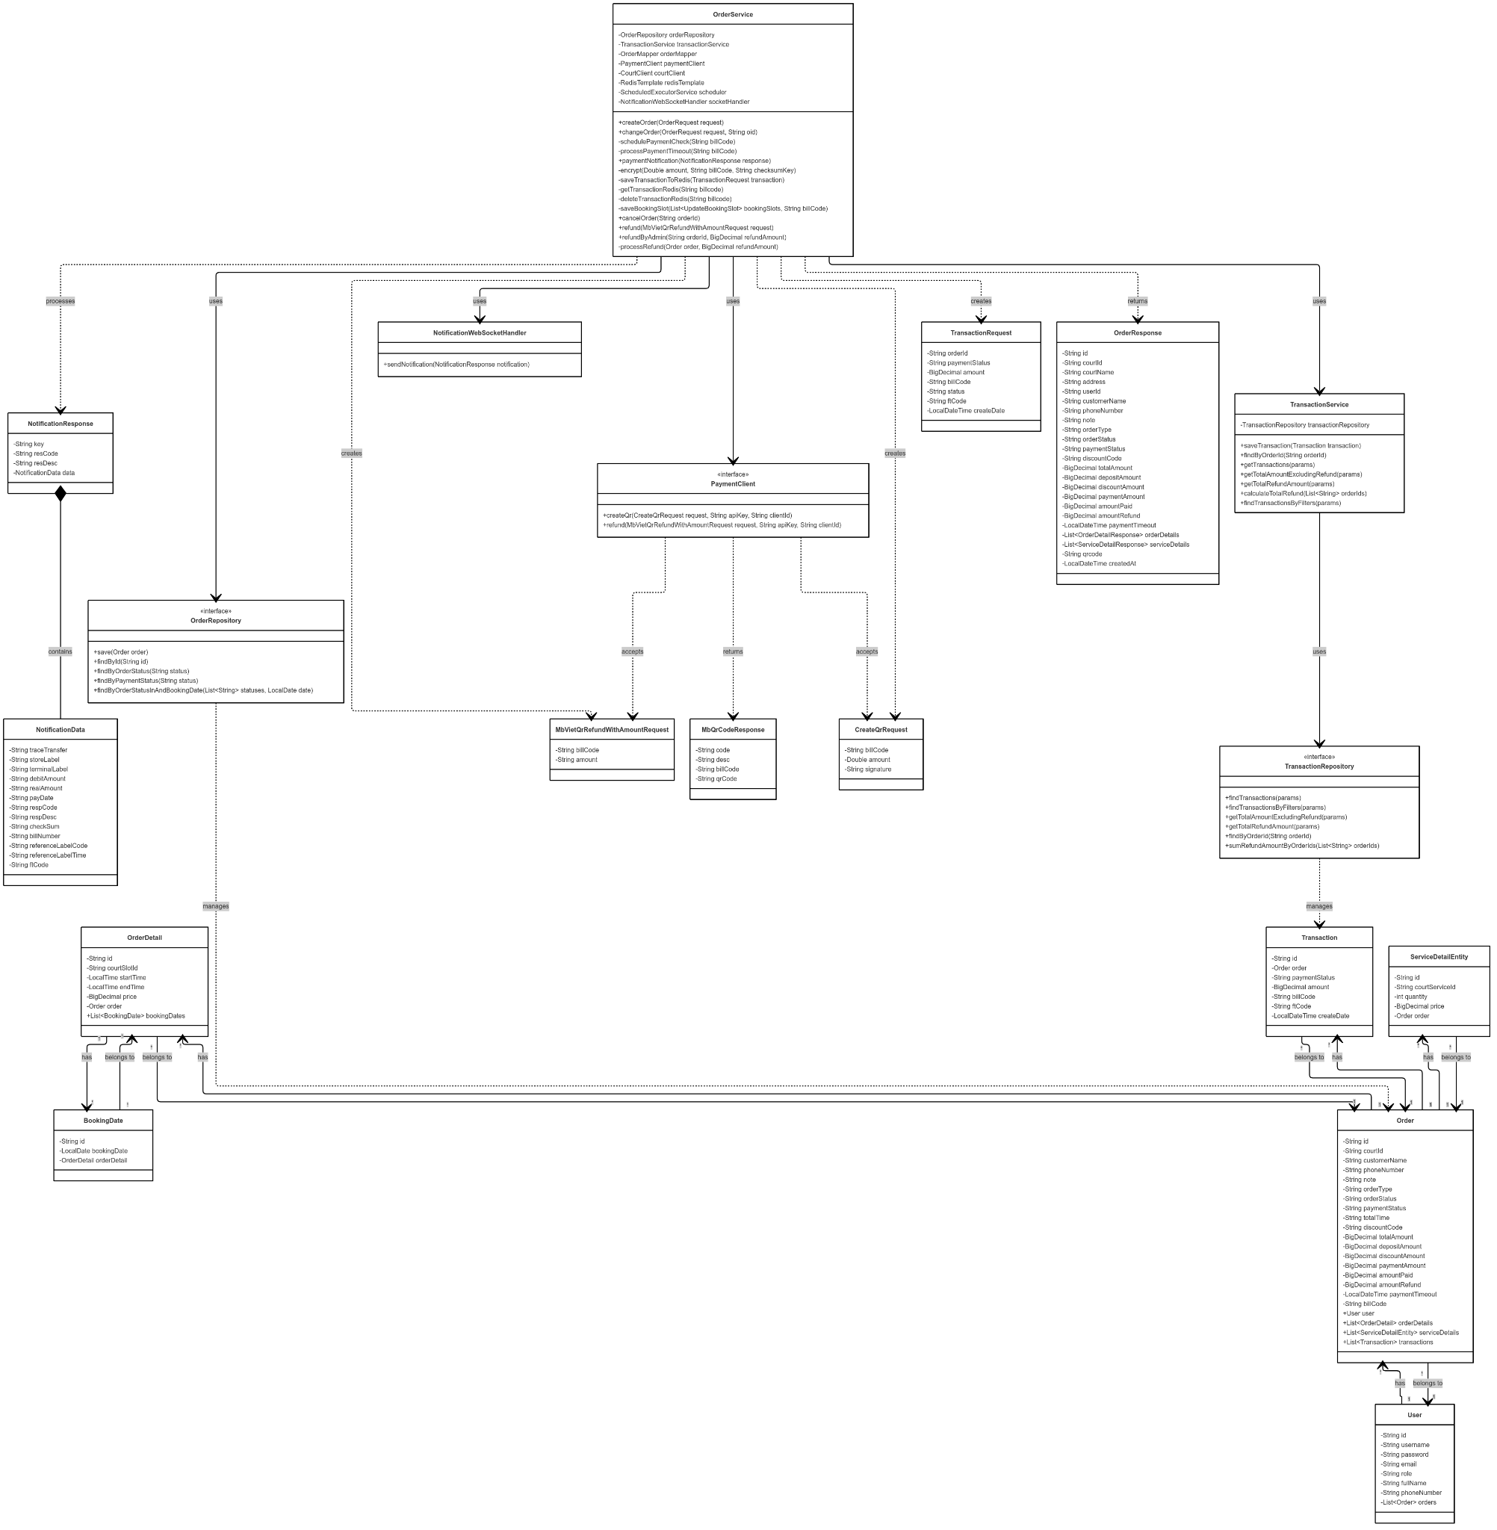

Link image: https://iili.io/3WUOWG9.png

##### *3.2.4.1.2 Sequence Diagram*

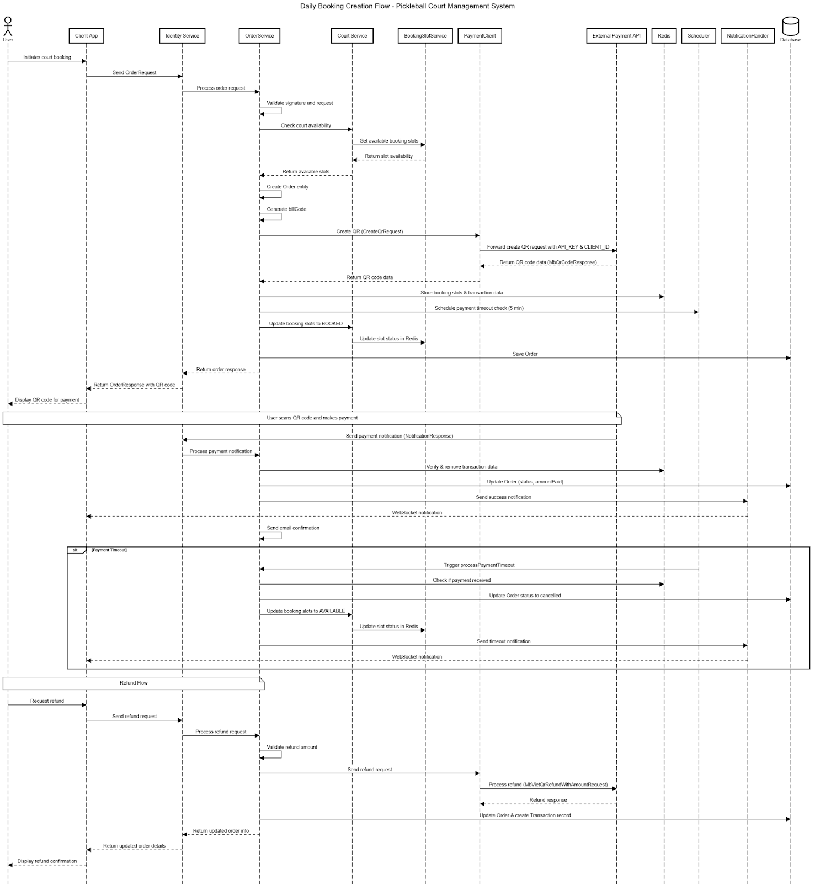

Link image: https://iili.io/3WXXkOl.png

##### 

##### *3.2.4.2 Slot Availability Checking*

##### *3.2.4.2.1 Class Diagram*

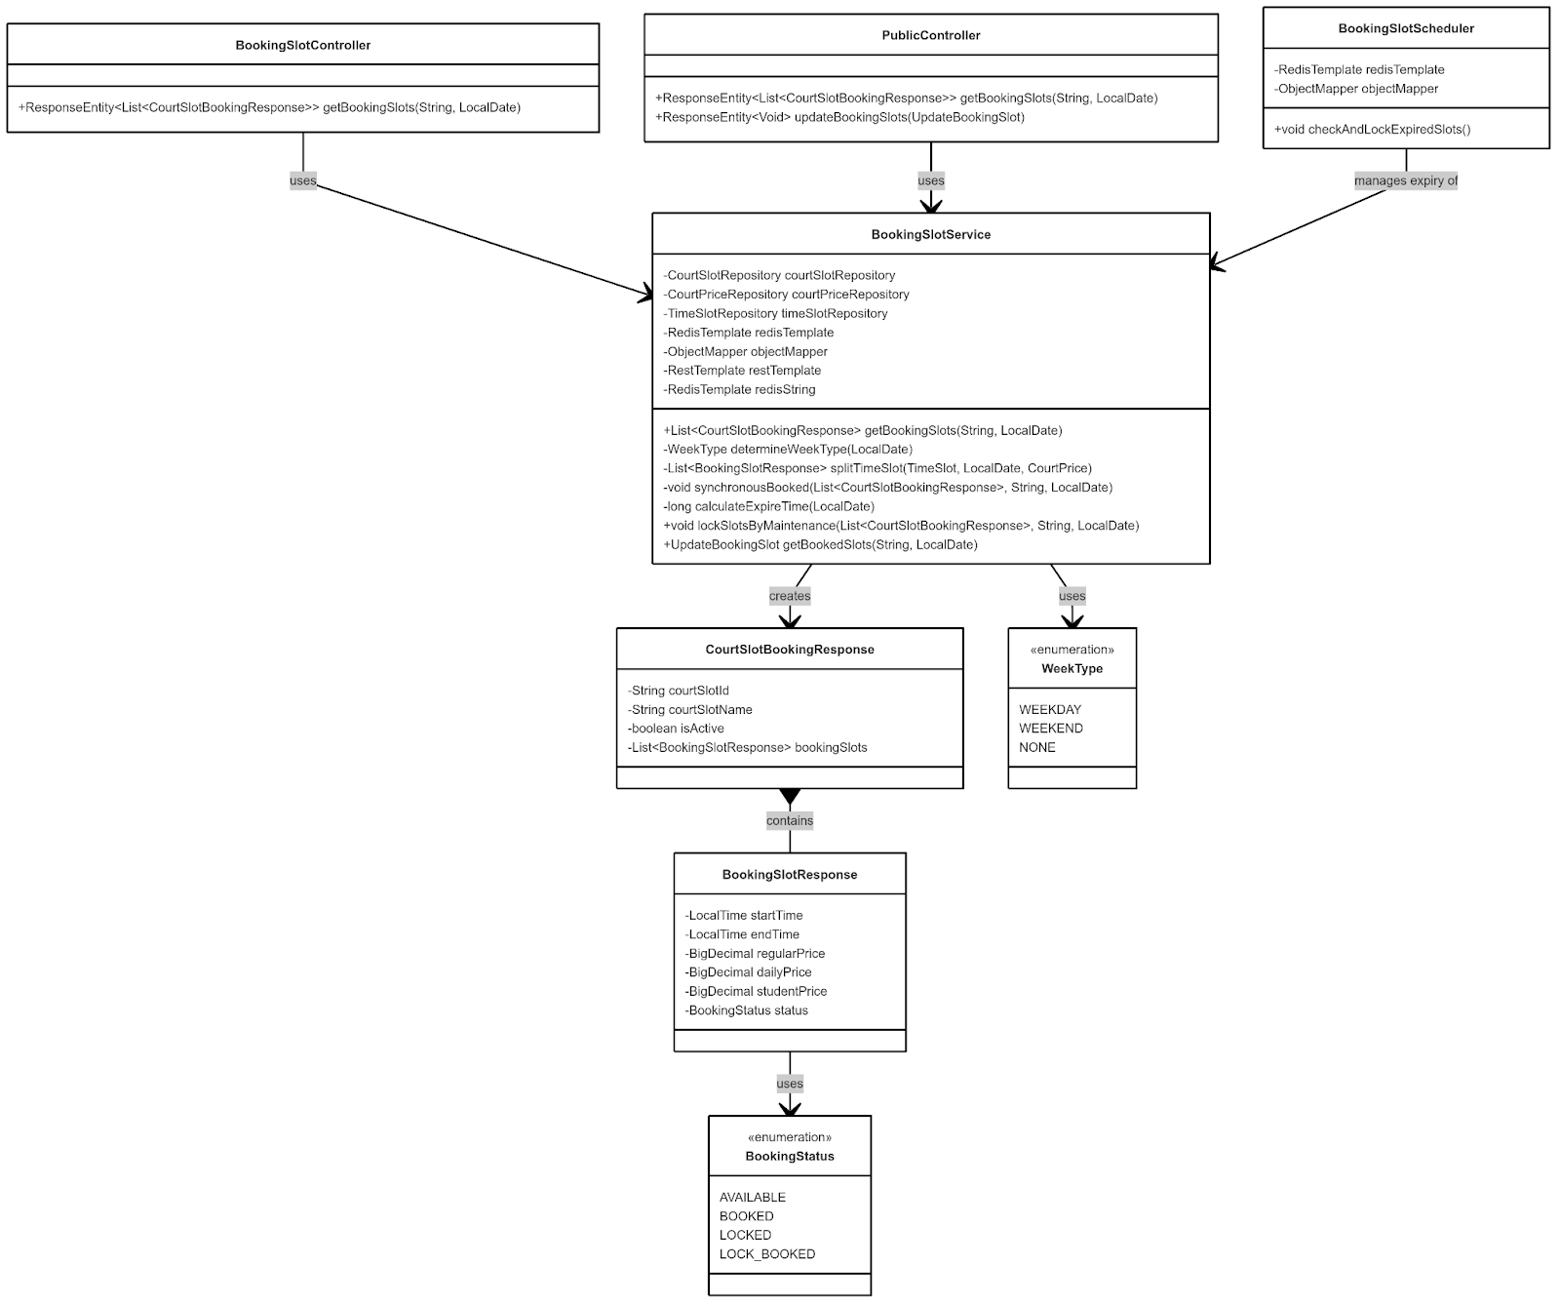

##### *3.2.4.2.2 Sequence Diagram*

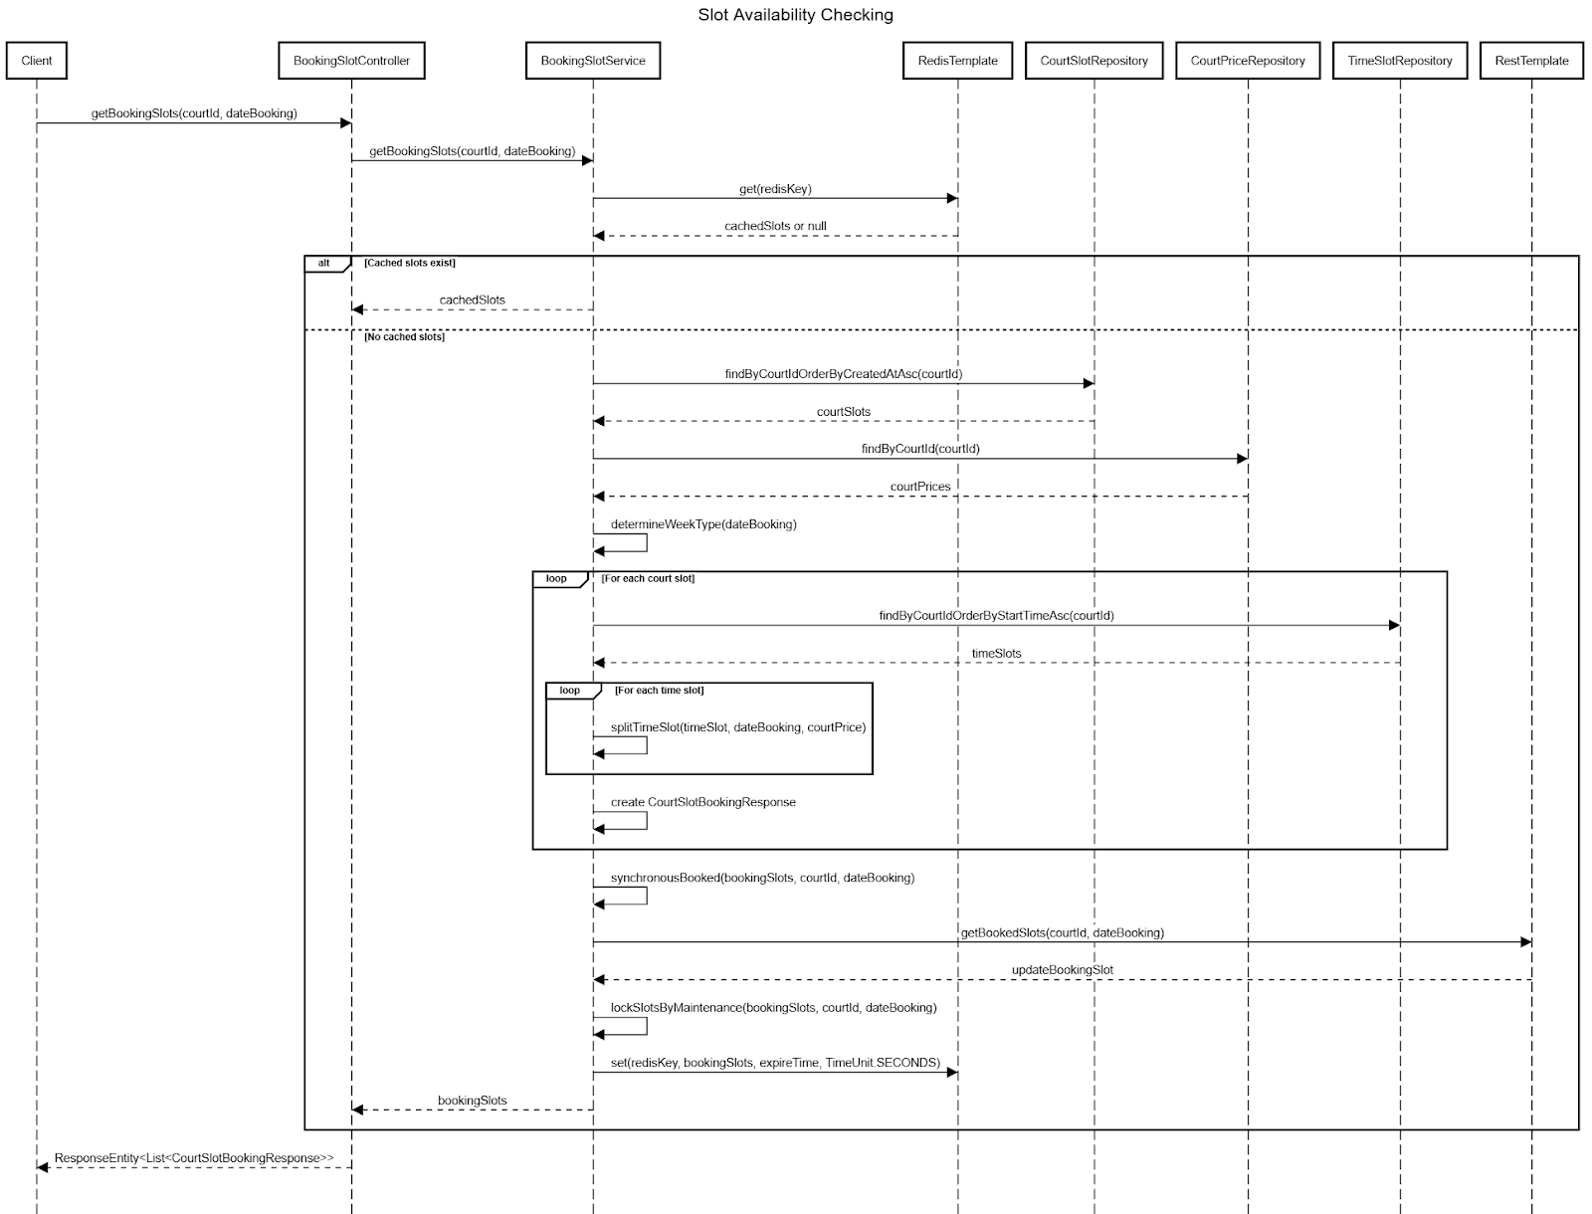

##### *3.2.4.4 Booking Status Transitions*

##### *3.2.4.4.1 Class Diagram*

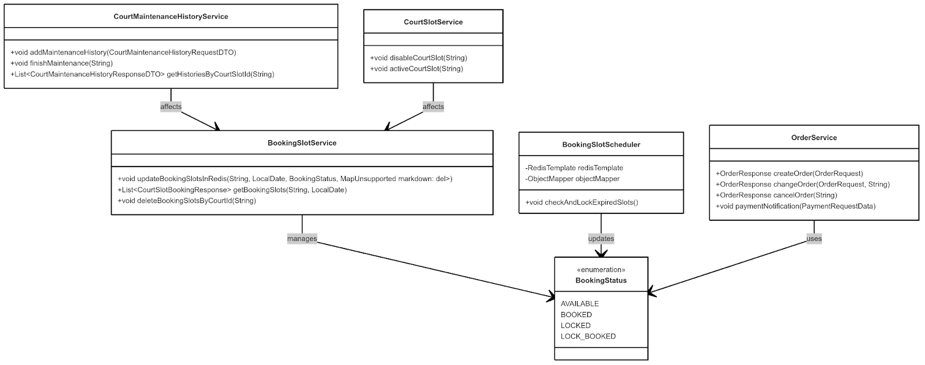

##### *3.2.4.4.2 Sequence Diagram*

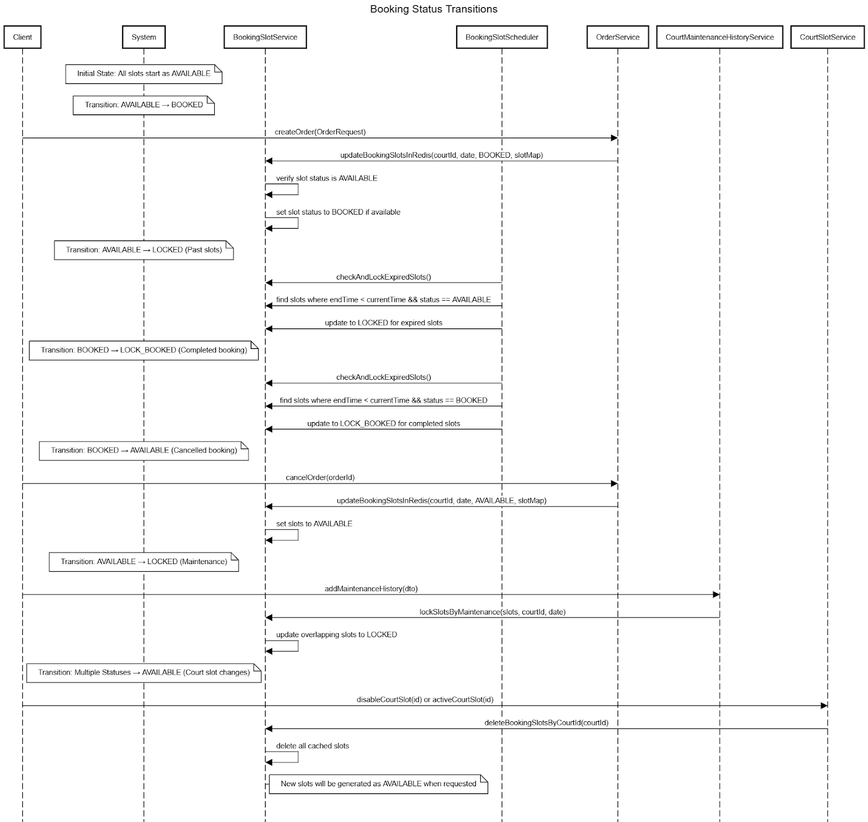

##### *3.2.4.5 Change Booking*

##### *3.2.4.5.1 Class Diagram*

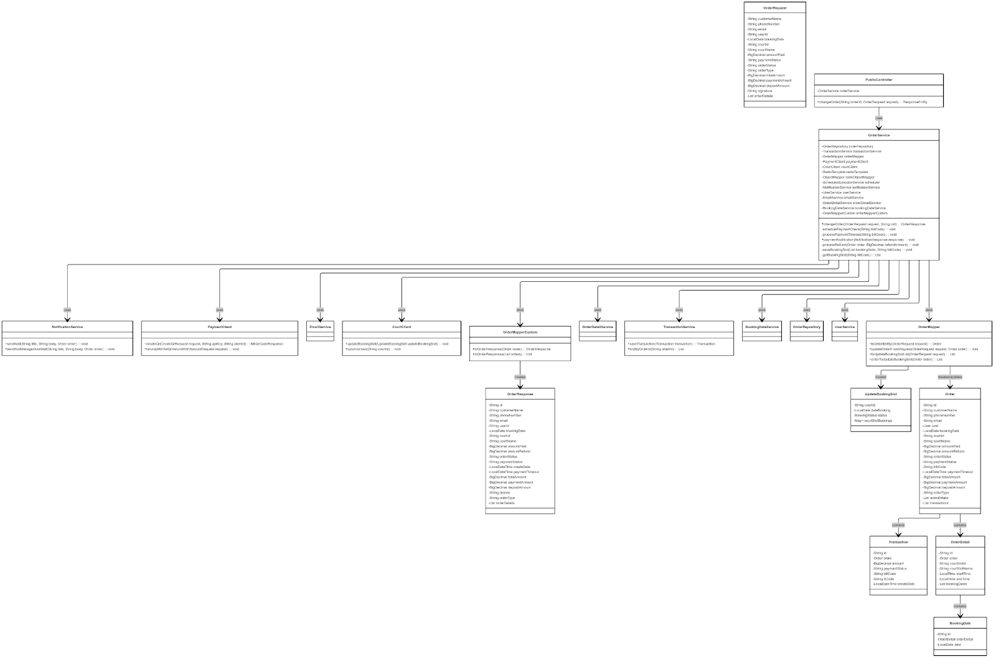

Link image: https://iili.io/3WXQYHx.png

##### *3.2.4.5.2 Sequence Diagram*

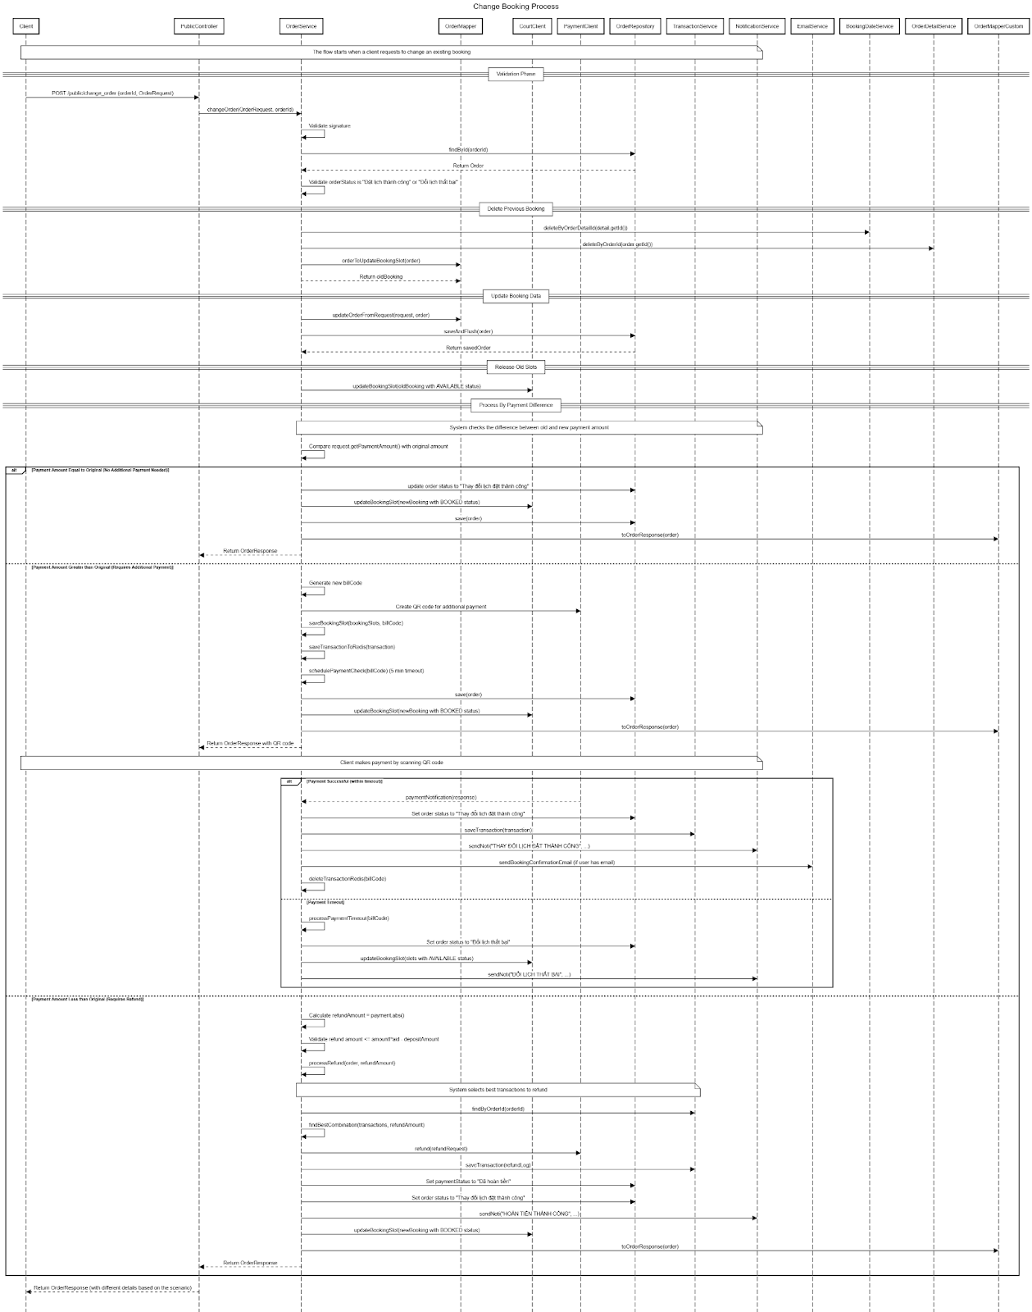

Link image: <https://iili.io/3WXLFpV.png>

##### *3.2.4.6 Fixed Booking process*

##### *3.2.4.6.1 Class Diagram*

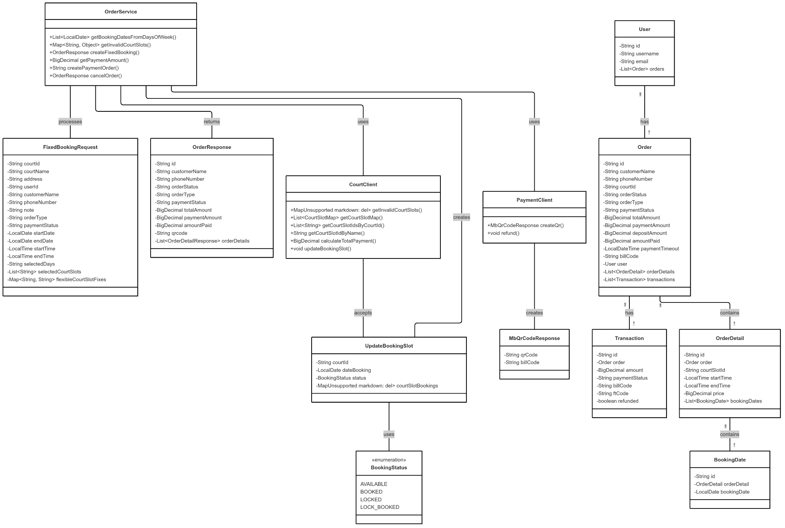

##### *3.2.4.6.2 Sequence diagram*

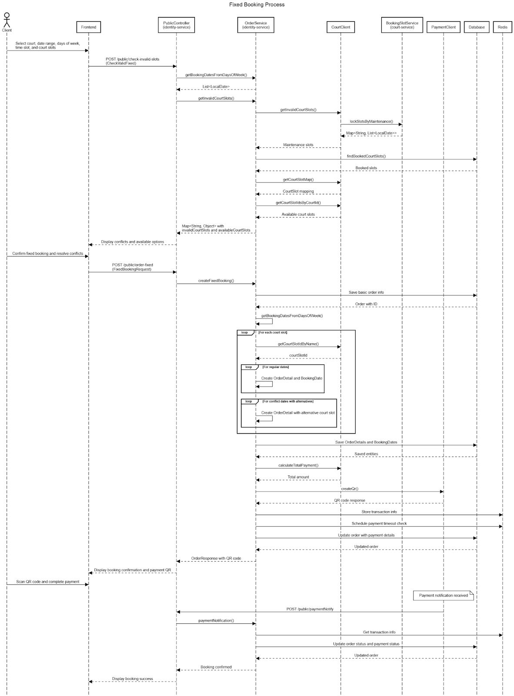

##### *3.2.5.2 QR Code Payment Generation*

##### *3.2.5.2.1 Class Diagram*

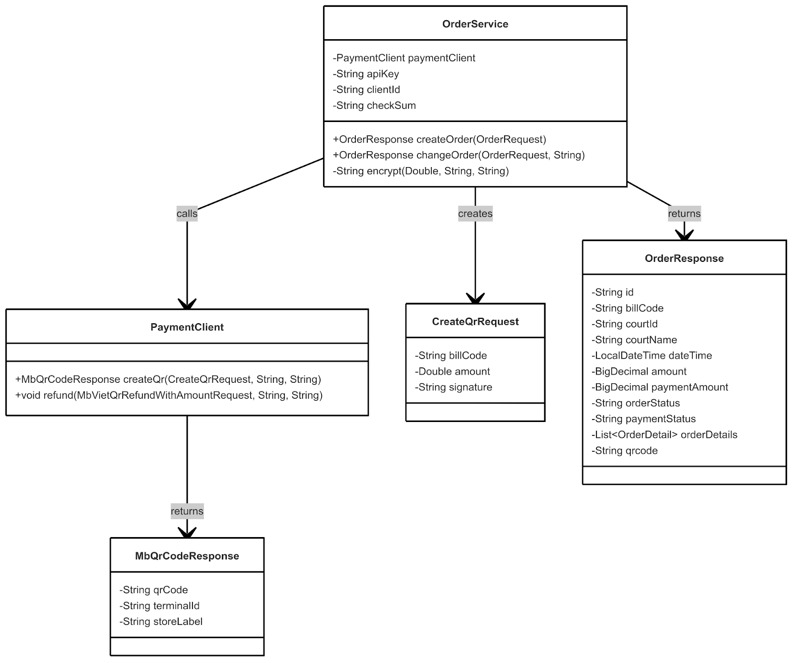

##### *3.2.5.2.2 Sequence Diagram*

##### 

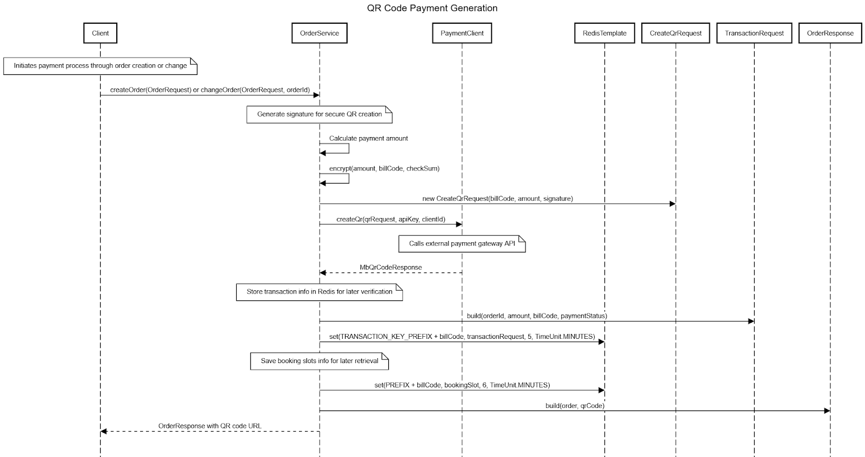

##### *3.2.5.3 Transaction Processing*

##### *3.2.5.3.1 Class Diagram*

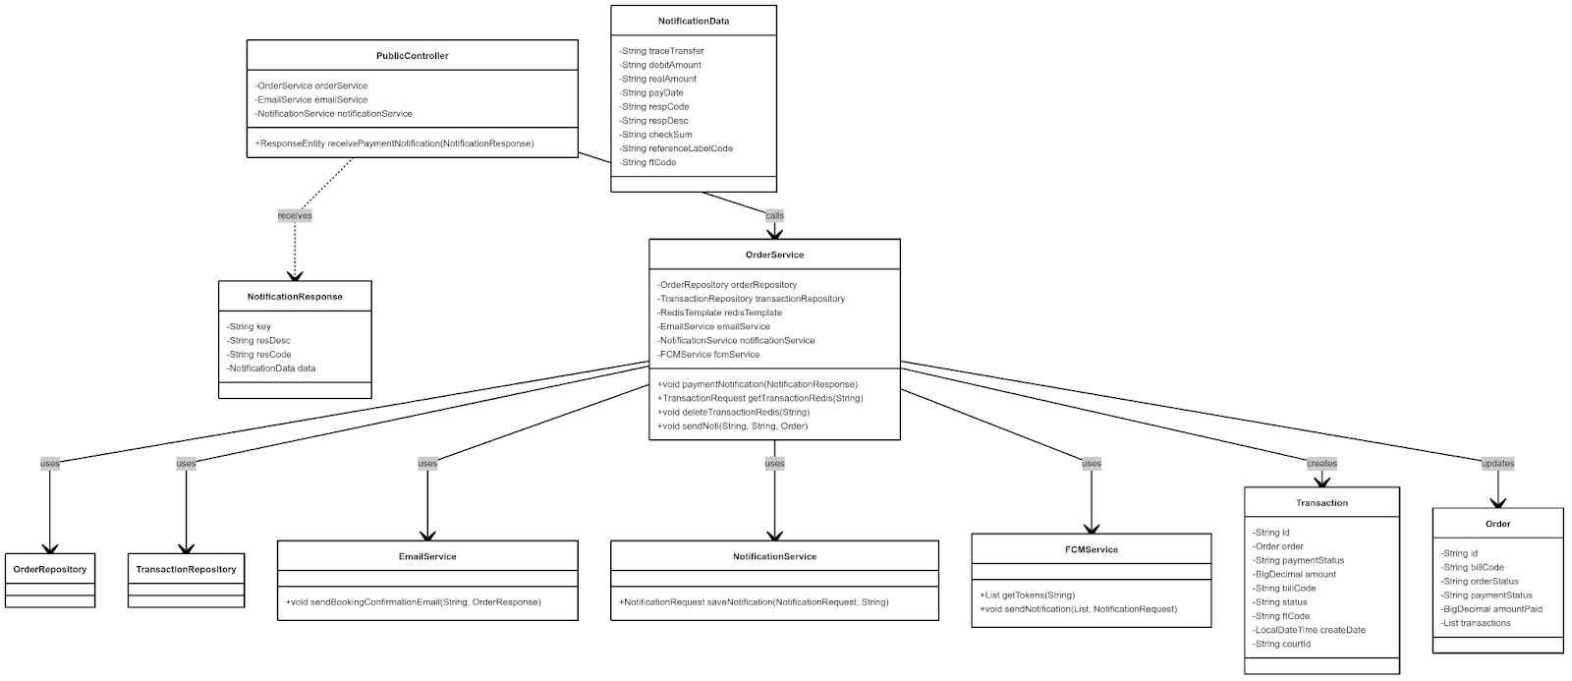

##### *3.2.5.3.2 Sequence Diagram*

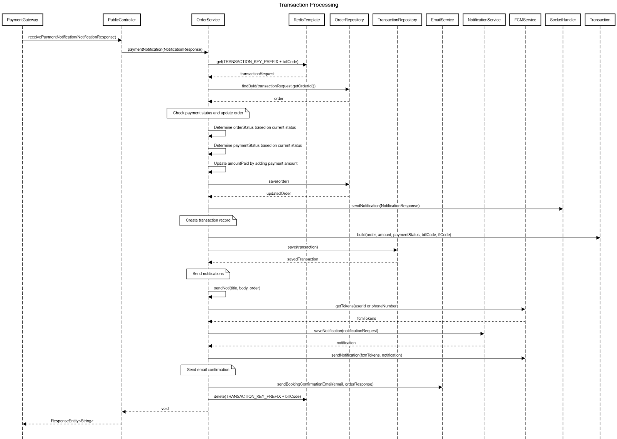

##### *3.2.5.4 Refund Handling*

##### *3.2.5.4.1 Class Diagram*

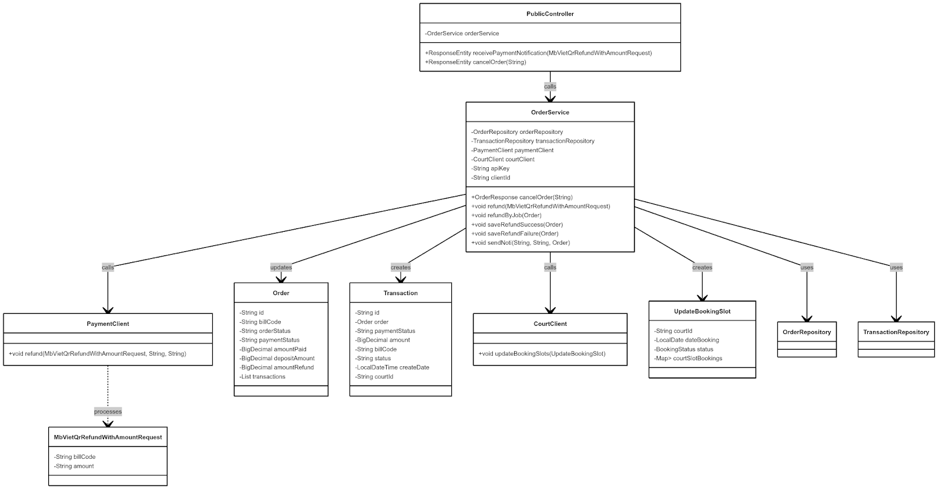

##### *3.2.5.4.2 Sequence Diagram*

##### *3.2.5.4.2.1 Order Cancellation*

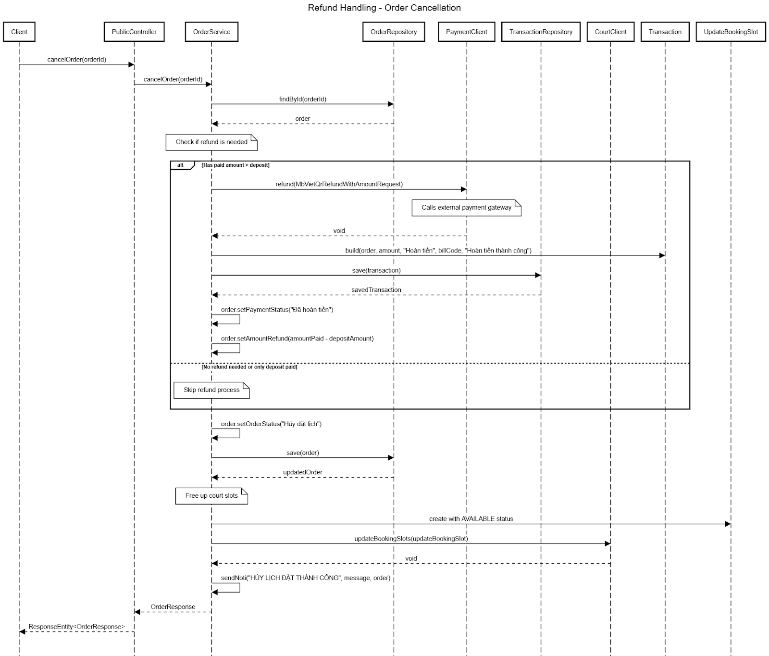

##### *3.2.5.4.2.2 Direct Refund Processing*

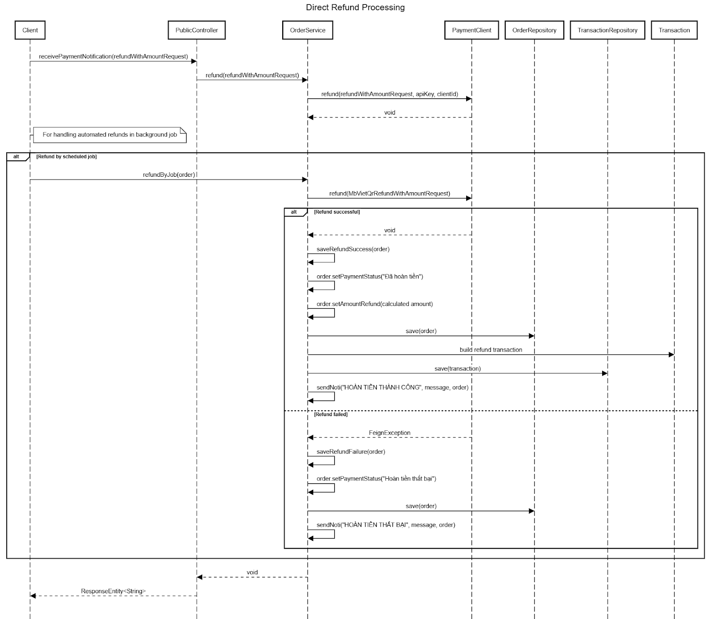

##### *3.2.5.4.2.3 Refund During Order Change*

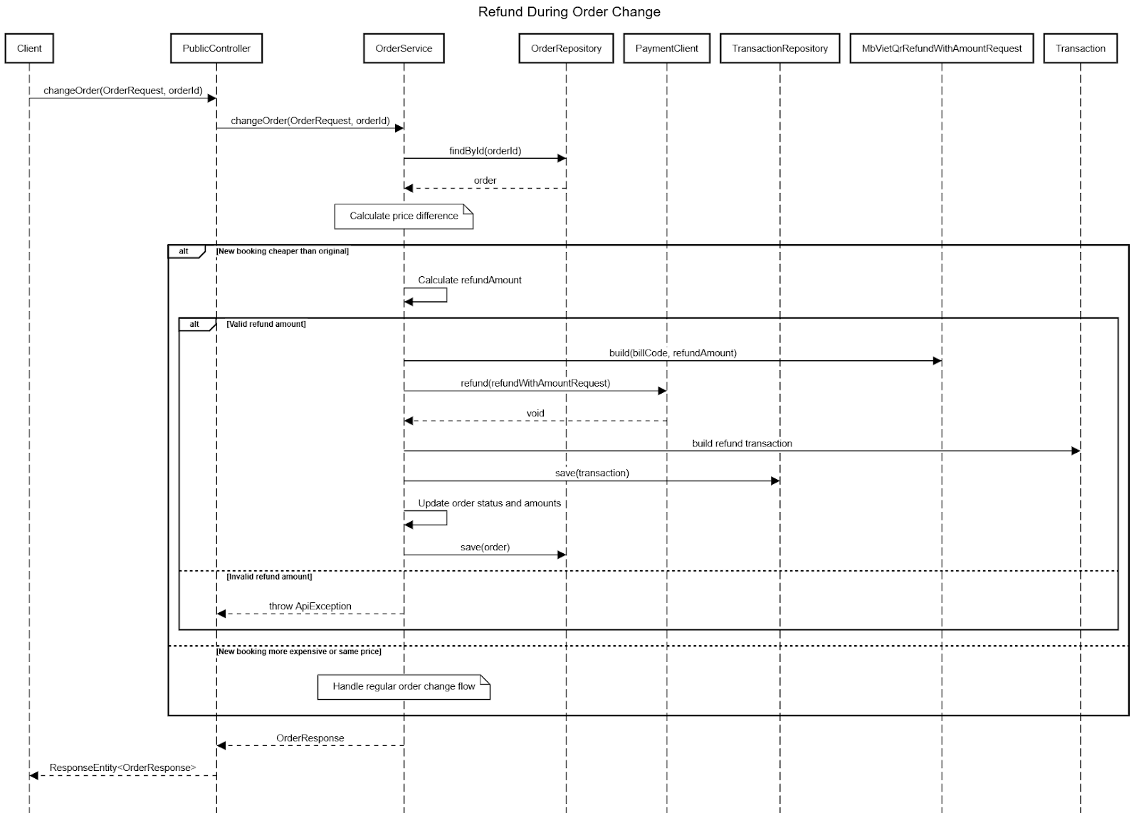

## 4. Class Specifications

### *4.1 Controller*

#### 4.1.1. UserController

| Methods | | |
| --- | --- | --- |
| Name | Type | Description |
| createUser | ApiResponse<UserResponse> | Creates a new user account |
| registerForStudent | String | Registers a new student user and returns a confirmation message |
| getUsers | ApiResponse<List<UserResponse>> | Retrieves all users in the system |
| getUsersWithRole | ApiResponse<List<UserResponse>> | Retrieves all users with a specified role |
| getUser | ApiResponse<UserResponse> | Gets a specific user by their ID |
| getMyInfo | ApiResponse<UserResponse> | Retrieves the current authenticated user's information |
| deleteUser | ApiResponse<String> | Removes a user from the system by ID |
| updateUser | ApiResponse<UserResponse> | Updates the current user's profile information |
| updateUserByAdmin | ApiResponse<UserResponse> | Admin-only method to update any user's information |
| createUserByAdmin | ApiResponse<UserResponse> | Admin-only method to create new user accounts |

#### 4.1.2. AuthenticationController

| Methods | | |
| --- | --- | --- |
| Name | Type | Description |
| authenticate (token) | ApiResponse<AuthenticationResponse> | Authenticates a user and issues access/refresh tokens |
| authenticate (introspect) | ApiResponse<IntrospectResponse> | Validates and provides information about an existing token |
| authenticate (refresh) | ApiResponse<AuthenticationResponse> | Issues new tokens using a valid refresh token |
| logout | ApiResponse<Void> | Invalidates a user's current tokens |
| confirmStudent | ApiResponse<UserResponse> | Verifies a student account using a confirmation key |
| forgetPass | void | Initiates password reset process for a user |

#### 4.1.3. AdminDashboardController

| Methods | | |
| --- | --- | --- |
| Name | Type | Description |
| getTransactions | TransactionResponse | Retrieves filtered and paginated transaction data with summary |
| getOrders | OrderPage | Retrieves filtered and paginated order information |
| getTransactionsByOid | List<TransactionDto> | Retrieves all transactions associated with a specific order ID |
| getRevenueSummary | ResponseEntity<RevenueSummaryResponse> | Get a summary report of revenue |
| analyzeOccupancy | ResponseEntity<OccupancyAnalysisResponse> | occupancy rate statistical analysis |
| analyzePeakHours | ResponseEntity<PeakHoursAnalysisResponse> | rush hour analysis |

#### 4.1.4. ManagerOrderController

| Methods | | |
| --- | --- | --- |
| Name | Type | Description |
| getOrdersByFilter | ResponseEntity<OrderPage> | Get order with filter |
| checkin | ResponseEntity<OrderResponse> | checkin when user arrives at court |

#### 

#### 

#### 

#### 4.1.5. RoleController

| Methods | | |
| --- | --- | --- |
| Name | Type | Description |
| create | ApiResponse<RoleResponse> | Creates a new role in the system |
| update | ApiResponse<RoleResponse> | Updates an existing role definition |
| delete | ApiResponse<Void> | Removes a role from the system |
| getAll | ApiResponse<List<RoleResponse>> | Retrieves all roles defined in the system |

#### 

#### 

#### 

#### 

#### 4.1.6. CourtController

| Methods | | |
| --- | --- | --- |
| Name | Type | Description |
| createCourt | ResponseEntity<CourtResponse> | Creates a new pickleball court |
| getAllCourts | ResponseEntity<List<CourtResponse>> | Retrieves all courts in the system |
| getCourtById | ResponseEntity<CourtResponse> | Gets a specific court by its ID |
| getCourtsByManager | ResponseEntity<List<CourtResponse>> | Retrieves all courts managed by the current user |
| getCourtDetail | ResponseEntity<CourtDetail> | Retrieves detailed information about a specific court |
| updateCourt | ResponseEntity<CourtResponse> | Updates court information |
| deleteCourt | ResponseEntity<Void> | Removes a court from the system |
| disableCourt | ResponseEntity<Void> | Temporarily deactivates a court |
| activeCourt | ResponseEntity<Void> | Reactivates a previously disabled court |
| getAllPage | PageResponse<CourtResponse> | Retrieves paginated and searchable court data |
| uploadLogo | String | Uploads a logo image for a court |
| uploadBackground | String | Uploads a background image for a court |

#### 4.1.7. CourtImageController

| Methods | | |
| --- | --- | --- |
| Name | Type | Description |
| uploadCourtImage | ResponseEntity<CourtImage> | Uploads an image for a court |
| deleteCourtImage | ResponseEntity<Void> | Removes a court image |

#### 4.1.8.BookingSlotController

| Methods | | |
| --- | --- | --- |
| Name | Type | Description |
| getBookingSlots | ResponseEntity<List<CourtSlotBookingResponse>> | Retrieves available booking slots for a court on a specific date |

#### 4.1.9.CourtPriceController

| Methods | | |
| --- | --- | --- |
| Name | Type | Description |
| createOrUpdateCourtPrice | ResponseEntity<CourtPriceResponse> | Creates or updates pricing for a court |
| getCourtPriceByCourtId | ResponseEntity<CourtPriceResponse> | Retrieves pricing information for a specific court |

#### 4.1.10. CourtSlotController

| Methods | | |
| --- | --- | --- |
| Name | Type | Description |
| createCourtSlot | ResponseEntity<CourtSlotResponse> | Creates a new time slot for court booking |
| getCourtSlotById | ResponseEntity<CourtSlotResponse> | Gets a specific court slot by ID |
| getAllCourtSlots | ResponseEntity<List<CourtSlotResponse>> | Retrieves all court slots in the system |
| updateCourtSlot | ResponseEntity<CourtSlotResponse> | Updates court slot information |
| deleteCourtSlot | ResponseEntity<Void> | Removes a court slot from the system |
| disableCourtSlot | ResponseEntity<Void> | Temporarily deactivates a court slot |
| activeCourtSlot | ResponseEntity<Void> | Reactivates a previously disabled court slot |
| getCourtSlotsByCourtId | ResponseEntity<List<CourtSlotResponse>> | Retrieves all slots for a specific court |
| addMaintenanceHistory | void | Records a new maintenance event for a court slot |
| getHistories | List<CourtMaintenanceHistoryResponseDTO> | Retrieves maintenance history for a court slot |
| finishMaintenance | void | Marks a maintenance event as completed |

#### 

#### 

#### 4.1.11. PublicController

| Methods | | |
| --- | --- | --- |
| Name | Type | Description |
| getCourtSlotById | ResponseEntity<CourtSlotResponse> | Public access to court slot information |
| getAllCourtSlots | ResponseEntity<List<CourtSlotResponse>> | Public access to all court slots active |
| getCourtSlotsByCourtId | ResponseEntity<List<CourtSlotResponse>> | Public access to court slots active by court ID |
| getCourtPriceByCourtId | ResponseEntity<CourtPriceResponse> | Public access to court pricing information |
| getBookingSlots | ResponseEntity<List<CourtSlotBookingResponse>> | Public access to available booking slots |
| updateBookingSlots | ResponseEntity<Void> | Updates booking slot information in Redis |
| getCourtImages | ResponseEntity<List<CourtImage>> | Public access to court images |
| createOrder | ResponseEntity<OrderResponse> | Public access to create order |
| changeOrder | ResponseEntity<OrderResponse> | Public access to change order |
| getOrders | ResponseEntity<Danh sách<OrderResponse>> | Public access to get history order |
| getOrderById | ResponseEntity<OrderResponse> | Public access to get order detail |
| getAllNotifications | ResponseEntity<NotificationResponse> | Public access to get list notification |
| createFixedBooking | ResponseEntity<OrderResponse> | Public access to create fix order |

### *4.2 Service*

#### 4.2.1. UserService

| Methods | | |
| --- | --- | --- |
| Name | Type | Description |
| createUser | UserResponse | Creates a new regular user account |
| registerStudent | String | Registers a student user and returns confirmation message |
| getUsers | List<UserResponse> | Retrieves all users with a specified role |
| getUser | UserResponse | Gets a specific user by their ID |
| getMyInfo | UserResponse | Gets the current authenticated user's information |
| deleteUser | void | Deletes a user from the system by ID |
| updateUser | UserResponse | Updates the current user's profile information |
| updateUserByAdmin | UserResponse | Admin-only method to update any user's information |
| createUserByAdmin | UserResponse | Admin-only method to create new user accounts |
| ChangeMyPassword | Task | Changes the current user's password |
| ChangePass | Task | Changes passwords for users based on requirements |

Table 4.2.3: Class Specifications - UserService

#### 4.2.2. AuthenticationService

| Methods | | |
| --- | --- | --- |
| Name | Type | Description |
| authenticate | AuthenticationResponse | Authenticates a user and issues access/refresh tokens |
| validateToken | boolean | Validates if a token is legitimate and not expired |
| refreshToken | AuthenticationResponse | Issues new tokens using a valid refresh token |
| logout | void | Invalidates a user's current tokens |
| confirmStudent | UserResponse | Verifies a student account using confirmation key |
| forgetPassword | void | Initiates password reset process for a user |

Table 4.14: Class Specifications - AuthenticationService

#### 4.2.3. RoleService

| Methods | | |
| --- | --- | --- |
| Name | Type | Description |
| createRole | RoleResponse | Creates a new role in the system |
| updateRole | RoleResponse | Updates an existing role definition |
| getAllRoles | List<RoleResponse> | Retrieves all roles defined in the system |
| deleteRole | void | Removes a role from the system |
| assignRolesToUser | void | Assigns multiple roles to a specific user |

Table 4.16: Class Specifications - RoleService

#### 4.2.5. CourtService

| Methods | | |
| --- | --- | --- |
| Name | Type | Description |
| createCourt | CourtResponse | Creates a new pickleball court |
| getAllCourts | List<CourtResponse> | Retrieves all courts in the system |
| getCourtById | CourtResponse | Gets a specific court by its ID |
| getCourtsByManager | List<CourtResponse> | Retrieves courts managed by current user |
| getCourtDetail | CourtDetail | Gets detailed information about a court |
| updateCourt | CourtResponse | Updates court information |
| deleteCourt | void | Removes a court from the system |
| disableCourt | void | Temporarily deactivates a court |
| activateCourt | void | Reactivates a previously disabled court |
| getAllCourtsPaginated | PageResponse<CourtResponse> | Gets paginated and searchable court data |
| uploadLogo | String | Uploads a logo image for a court |
| uploadBackground | String | Uploads a background image for a court |

Table 4.18: Class Specifications - CourtService

#### 4.2.6. CourtImageService

#### 

| Methods | | |
| --- | --- | --- |
| Name | Type | Description |
| uploadCourtImage | CourtImage | Uploads an image for a court |
| deleteCourtImage | void | Removes a court image |
| getCourtImages | List<CourtImage> | Retrieves all images for a specific court |

Table 4.19: Class Specifications - CourtImageService

#### 4.2.7. BookingSlotService

| Methods | | |
| --- | --- | --- |
| Name | Type | Description |
| getBookingSlots | List<CourtSlotBookingResponse> | Retrieves available booking slots for a court on a date |
| updateBookingSlots | void | Updates booking slot information in Redis |
| reserveSlot | ReservationResponse | Temporarily reserves a booking slot |
| confirmBooking | BookingConfirmationResponse | Confirms a previously reserved booking |

Table 4.20: Class Specifications - BookingSlotService

#### 4.2.8. CourtPriceService

| Methods | | |
| --- | --- | --- |
| Name | Type | Description |
| createOrUpdateCourtPrice | CourtPriceResponse | Creates or updates pricing for a court |
| getCourtPriceByCourtId | CourtPriceResponse | Retrieves pricing information for a specific court |
| calculateFee | BookingFeeResponse | Calculates the booking fee based on slot and duration |

Table 4.21: Class Specifications - CourtPriceService

#### 4.2.9. CourtSlotService

| Methods | | |
| --- | --- | --- |
| Name | Type | Description |
| createCourtSlot | CourtSlotResponse | Creates a new time slot for court booking |
| getCourtSlotById | CourtSlotResponse | Gets a specific court slot by ID |
| getAllCourtSlots | List<CourtSlotResponse> | Retrieves all court slots in the system |
| updateCourtSlot | CourtSlotResponse | Updates court slot information |
| deleteCourtSlot | void | Removes a court slot from the system |
| disableCourtSlot | void | Temporarily deactivates a court slot |
| activateCourtSlot | void | Reactivates a previously disabled court slot |
| getCourtSlotsByCourtId | List<CourtSlotResponse> | Retrieves all slots for a specific court |
| addMaintenanceHistory | void | Records a maintenance event for a court slot |
| getMaintenanceHistories | List<CourtMaintenanceHistoryResponseDTO> | Gets maintenance history for a court slot |
| finishMaintenance | void | Marks a maintenance event as completed |
| checkAvailability | SlotAvailabilityResponse | Checks if a slot is available for booking |

Table 4.22: Class Specifications - CourtSlotService

#### 4.2.10. MaintenanceService

| Methods | | |
| --- | --- | --- |
| Name | Type | Description |
| scheduleMaintenance | MaintenanceResponse | Schedules a new maintenance event |
| updateMaintenance | MaintenanceResponse | Updates maintenance event details |
| cancelMaintenance | void | Cancels a scheduled maintenance event |
| completeMaintenance | MaintenanceResponse | Marks a maintenance event as completed |
| getUpcomingMaintenance | MaintenanceResponse | Gets upcoming maintenance events |

Table 4.23: Class Specifications - MaintenanceService

#### 4.2.11. Order Service

| Methods | | |
| --- | --- | --- |
| Name | Type | Description |
| createOrder | ResponseEntity<OrderResponse> | Public access to create order |
| changeOrder | ResponseEntity<OrderResponse> | Public access to change order |
| getOrders | ResponseEntity<Danh sách<OrderResponse>> | Public access to get history order |
| getOrderById | ResponseEntity<OrderResponse> | Public access to get order detail |
| getAllNotifications | ResponseEntity<NotificationResponse> | Public access to get list notification |
| createFixedBooking | ResponseEntity<OrderResponse> | Public access to create fix order |

Table 4.24: Class Specifications - Booking Service

### *4.3 Entity*

#### 4.3.1 User

| Attributes | | |
| --- | --- | --- |
| Name | Type | Description |
| id | String | Unique identifier (36 characters) |
| username | String | User's login name (unique) |
| email | String | User's email address (unique, not updatable) |
| phoneNumber | String | User's phone number (unique) |
| isStudent | Boolean | Indicates if user is a student |
| Password | String | User’s login password |
| Gender | ENUM(MALE/FREMALE) | User’s gender |
| firstName | String | User’s fisrt name |
| lastName | String | User’s last name |
| roles | Set<Role> | Roles user assign |
| courtStaffs | Set<CourtStaff> | Courts user assign |
| createdAt | LocalDateTime | When the record was created |
| lastModifiedAt | LocalDateTime | When the record was last updated |
| isDeleted | Boolean | Soft delete flag (default: false) |

Table 4.25: Class Specifications - User

#### 4.3.2 Role

| Attributes | | |
| --- | --- | --- |
| Name | Type | Description |
| roleName | String | Role name |
| description | String | description |

#### 4.3.4 Notification

| Attributes | | |
| --- | --- | --- |
| Name | Type | Description |
| id | String | Unique identifier (36 characters) |
| use | User | User receicer notification |
| title | String | Notification title |
| description | String | Notification description |
| Status | String | Whether notification has been read |
| notificationData | String | Addition information |
| createdAt | LocalDateTime | When the notification was created |

Table 4.27: Class Specifications - Notification

#### 4.3.5 Order

| Attributes | | |
| --- | --- | --- |
| Name | Type | Description |
| id | String | Unique identifier (36 characters) |
| userId | String | User who placed the order |
| courtId | String | Court being booked |
| orderStatus | String/Enum | Status of the order |
| paymentStatus | String/Enum | Status of payment |
| totalAmount | BigDecimal | Total amount of the order |
| discountAmount | BigDecimal | Discount Amount |
| depositAmount | BigDecimal | Deposit Amount |
| paymentAmount | BigDecimal | Payment Amount |
| amountPaid | BigDecimal | Amount Paid |
| amountRefund | BigDecimal | Amount Refund |
| notes | String | Additional notes |
| orderDetails | List<OrderDetail> | Orders detail in order |
| serviceDetails | List<ServiceDetailEntity> | Order service detail |
| transactions | List<Transaction> | List transaction of order |
| createdAt | LocalDateTime | When the order was created |
| lastModifiedAt | LocalDateTime | When the order was last updated |
| isDeleted | Boolean | Soft delete flag (default: false) |

Table 4.28: Class Specifications - Order

#### 4.3.6 OrderDetail Entity

| Attributes | | |
| --- | --- | --- |
| Name | Type | Description |
| id | String | Unique identifier (36 characters) |
| courtSlotId | String | Associated order slot ID |
| startTime | LocalTime | Start time booking |
| endTime | LocalTime | End time booking |
| price | BigDecimal | Price of the booking |
| order | Order | Reference to order |
| bookingDates | List<BookingDate> | List<BookingDate> of order |

Table 4.29: OrderDetail Entity

#### 4.3.7 Transaction Entity

| Attributes | | |
| --- | --- | --- |
| Name | Type | Description |
| id | String | Unique identifier (36 characters) |
| order | Order | Associated order |
| amount | BigDecimal | Transaction amount |
| paymentStatus | String | Transaction status |
| paymentMethod | String/Enum | Payment method used |
| ftCode | String |  |
| billCode | String |  |
| createdAt | LocalDateTime | When the transaction was created |

Table 4.30: Transaction Entity

#### 4.3.8 Court Entity

| Attributes | | |
| --- | --- | --- |
| Name | Type | Description |
| id | String | Unique identifier (36 characters) |
| name | String | Court name (unique) |
| address | String | Court location |
| phone | String | Court phone number |
| openTime | String | Operating hours of the court |
| isActive | boolean | Flag indicating if the court is currently active |
| email | String | Email contact for the court |
| link | String | Website or other relevant link |
| logoUrl | String | URL to the court's logo image |
| backgroundUrl | String | URL to the court's background image |
| courtSlots | List<CourtSlot> | Court slot of court |
| timeSlots | List<TimeSlot> | TimeSlot of court |
| courtPrices | List<CourtPrice> | CourtPrice setting |
| courtImages | List<CourtImages> | CourtImage of court |
| courtService | List<CourtService> | CourtService of court |
| createdAt | LocalDateTime | When the record was created |
| lastModifiedAt | LocalDateTime | When the record was last updated |
| isDeleted | Boolean | Soft delete flag (default: true) |

Table 4.31: Court Entity

#### 4.3.9 CourtImage Entity

| Attributes | | |
| --- | --- | --- |
| Name | Type | Description |
| id | String | Unique identifier (36 characters) |
| court | Court | Reference court |
| imageUrl | String | URL to the court image |
| isMap | Boolean | Whether this is the map image |

Table 4.32: CourtImage Entity

#### 4.3.10 CourtPrice Entity

| Attributes | | |
| --- | --- | --- |
| Name | Type | Description |
| id | String | Unique identifier (36 characters) |
| court | Court | Associated court ID |
| timeSlot | TimeSlot | Associated time slot ID |
| weekType | Enum | Type of week (weekday/weekend) |
| regularPrice | BigDecimal | Regular price |
| studentPrice | BigDecimal | Price for students |
| isActive | Boolean | Whether this price is active |

Table 4.33: CourtPrice Entity

#### 4.3.11 CourtSlot Entity

| Attributes | | |
| --- | --- | --- |
| Name | Type | Description |
| id | String | Unique identifier (36 characters) |
| court | Court | Associated court ID |
| name | String | courtSlot name |
| isActive | Boolean | Whether the slot is active |
| createdAt | LocalDateTime | When the record was created |
| lastModifiedAt | LocalDateTime | When the record was last updated |
| isDeleted | Boolean | Soft delete flag (default: true) |

Table 4.34: CourtSlot Entity

#### 4.3.12 TimeSlot Entity

| Attributes | | |
| --- | --- | --- |
| Name | Type | Description |
| id | String | Unique identifier (36 characters) |
| court | Court | Associated court ID |
| courtPrice | CourtPrice | Associated courtPrice ID |
| startTime | LocalTime | Start time of the slot |
| endTime | LocalTime | End time of the slot |
| createdAt | LocalDateTime | When the record was created |
| lastModifiedAt | LocalDateTime | When the record was last updated |
| isDeleted | Boolean | Soft delete flag (default: true) |

Table 4.35: TimeSlot Entity

#### 4.3.13 OrderService Entity

| Attributes | | |
| --- | --- | --- |
| Name | Type | Description |
| id | String | Unique identifier (36 characters) |
| court | Court | Associated court ID |
| category | String | Category of the service (e.g., Equipment, Refreshments) |
| name | String | Name of the service |
| price | Double | Price of the service |
| quantity | Interger | Available quantity |
| unit | String | Unit of measure (e.g., hour, piece) |
| description | String | Detailed description |
| image_url | String | URL to an image representing the service |
| sold_count | Interger | Counter tracking how many times the service has been sold |
| isActive | Boolean | Whether the slot is active |
| createdAt | LocalDateTime | When the record was created |
| lastModifiedAt | LocalDateTime | When the record was last updated |
| isDeleted | Boolean | Soft delete flag (default: true) |

Table 4.36: BookingSlot Entity

#### 4.3.14 CourtMaintenanceHistory Entity

| Attributes | | |
| --- | --- | --- |
| Name | Type | Description |
| id | String | Unique identifier (36 characters) |
| court | Court | Associated court ID |
| startDate | LocalDateTime | Start date of maintenance |
| endDate | LocalDateTime | End date of maintenance |
| finishAt | LocalDateTime | Finish time of maintenance |
| description | String | Maintenance description (max 500 chars) |
| status | String | Status of maintenance |
| courtSlot | CourtSlot | Associated court slot ID |

Figure 4.3: Database Design

Table Descriptions

| No | Table | Description |
| --- | --- | --- |
| 1 | court | Stores primary information about pickleball courts including name, address, contact details, operating hours, and links. A court can have multiple court slots, time slots, prices, and services. |
| 2 | court_image | Contains images associated with courts. Each image can be marked as a map image (layout) or a regular photo of the facility with a corresponding URL. |
| 3 | court_service | Represents additional services offered by courts such as equipment rental or refreshments. Tracks category, name, price, quantity, unit, description, and sales data. |
| 4 | time_slot | Defines the available time periods for court bookings with start and end times. Each time slot is associated with a specific court and has corresponding pricing. |
| 5 | court_slot | Represents individual playing areas or courts within a facility. Each court slot has a name, active status, and can have maintenance history records. |
| 6 | court_maintenance_history | Tracks maintenance activities for court slots including start time, end time, completion time, description, and status. |
| 7 | court_price | Contains pricing information for court bookings based on time slot and week type (weekday/weekend). Includes different pricing tiers: regular, daily, and student prices. |
| 8 | orders | Stores booking order information including creation date, payment details, customer information, order status, payment method, and associated fees. |
| 9 | user | Contains user account information including email, password, name, contact details, role, and account status. |
| 10 | role | Defines user roles in the system such as administrator, staff, or regular user with corresponding permissions. |
| 11 | user_roles | Junction table that manages the many-to-many relationship between users and roles. |
| 12 | notification | Stores system notifications for users including creation date, description, notification date, contact information, and read status. |
| 13 | court_staff | Manages staff assigned to specific courts with their user IDs and court-specific roles. |
| 14 | transaction | Records financial transactions including amount, transaction ID, status, code, payment details, and associated order. |
| 15 | order_detail | Contains detailed information about each order including court slot, time slot, pricing, and booking status. |
| 16 | order_service_detail | Tracks additional services purchased as part of an order, including the service details, price, and quantity. |
| 17 | booking_slot | Manages the booking dates and associated order details for court reservations. |

Table 4.2: Table Descriptions Database Design